

Smart EV Security System Using GPS, GSM and Geofencing -

FINAL YEAR PROJECT PHASE-I REPORT
Submitted by
Priyanka K (23619130)
in partial fulfilment for the award of the degree of

BACHELOR OF TECHNOLOGY CSE - ARTIFICIAL INTELLIGENCE AND MACHINE LEARNING



DEPARTMENT OF ARTIFICIAL INTELLIGENCE AND MACHINE LEARNING SCHOOL OF ENGINEERING

VELS INSTITUTE OF SCIENCE, TECHNOLOGY AND ADVANCED STUDIES (VISTAS)

CHENNAI OCTOBER 2026

BONAFIDE CERTIFICATE

Certified that this project “Smart EV Security System Using GPS, GSM and Geofencing” is the bonafide work of Priyanka K(23619130), who carried out the project work under my supervision. Certified further that, to the best of my knowledge, the work reported here does not form part of any other project report or dissertation on the basis of which a degree or award was conferred on an earlier occasion on this or any other candidate.

SIGNATURE OF THE HOD SIGNATURE OF THE SUPERVISOR

Dr. K. Ulaga Priya M.E., Ph.D Mrs. Divya Bairavi S, ME., (PhD)
Mrs.Janani P, ME
Associate Professor & Head Department of AI & ML
Department of AI & ML School of Engineering
School of Engineering VISTAS
VISTAS Chennai-600117
Chennai-600117

Submitted for the Project Work and Viva-Voce examination held on ……………… at Vels Institute of Science, Technology and Advanced Studies (VISTAS), Chennai –600117.
.

INTERNAL EXAMINER EXTERNAL EXAMINER

ACKNOWLEDGEMENT

It is certainly a great delight and proud privilege to acknowledge the help and support I received from the positive minds around me in making this venture a successful one. The infrastructural support with all kinds of lab facilities have been a motivating factor in this completion of project work, all because of FOUNDER & CHAIRMAN, Shri. Dr. ISHARI K. GANESH., with great pleasure that I take this opportunity to thank him. I am grateful to our HEAD OF THE DEPARTMENT, Dr. K. Ulagapriya., for her continuous support for the project, from initial advice and contacts in the early stages of conceptual inception, and through on-going advice and encouragement to this day. I extend our warmest thanks to my INTERNAL GUIDE, Mrs. Divya Bairavi S, ME., (PhD), Mrs.Janani P,ME who has patiently guided and provided us with invaluable advice and help. I am thankful to my Project Coordinator Ms. S.J.Kavitha . I would like to express my greatest gratitude to our Staff members, Librarian, and Non-teaching staff members of Computer Centre, who have helped and supported me throughout. Last but not the Least, I wish to thank my parents and my friends for their individual support and interest who has inspired me and encouraged me to go in my own way, without them I would be unable to complete this project.

PRIYANKA K 23619130

TABLE OF CONTENTS
ABSTRACT .............................................. 6
LIST OF FIGURES ....................................... 7
LIST OF TABLES ........................................ 8
LIST OF ABBREVIATIONS ................................. 10
CHAPTER 1 INTRODUCTION ............................... 11
  - GENERAL ........................................ 11
  - PROBLEM DESCRIPTION ............................ 11
  - AIM ............................................ 12
  - OBJECTIVES ..................................... 12
  - SCOPE OF PHASE 1 ............................... 13
  - SIGNIFICANCE AND JUSTIFICATION ................. 13
  - DEVELOPMENT METHOD ............................. 14
CHAPTER 2 LITERATURE REVIEW AND RESEARCH GAP ......... 16
  - INTRODUCTION ................................... 16
  - RELATED WORK ................................... 16
  - EXISTING APPROACHES ............................ 18
  - RESEARCH AND IMPLEMENTATION GAPS ............... 19
  - TECHNOLOGY SELECTION AND JUSTIFICATION ......... 19
  - OBJECTIVE ALIGNMENT ............................ 20
  - CHAPTER SUMMARY ................................ 20
  - COMPARATIVE REVIEW OF GEOFENCE APPROACHES ........ 20
CHAPTER 3 SYSTEM DESIGN .............................. 22
  - DESIGN PRINCIPLES .............................. 22
  - SYSTEM ARCHITECTURE ............................ 22
  - DATA FLOW ...................................... 24
  - SYSTEM WORKFLOW ................................ 24
  - MAJOR SYSTEM MODULES ........................... 26
  - FUNCTIONAL REQUIREMENTS ........................ 26
  - NON-FUNCTIONAL REQUIREMENTS .................... 27
  - SOFTWARE AND HARDWARE REQUIREMENTS ............. 27
  - DATA STORAGE AND STATE ......................... 28
  - INPUT AND CONFIGURATION PROFILE ............... 28
  - APPLICATION STATE MODEL ....................... 29
  - DESIGN DECISIONS AND TRADE-OFFS ............... 29
  - COMPONENT BOUNDARIES AND DATA OWNERSHIP ........ 30
CHAPTER 4 IMPLEMENTATION AND METHODOLOGY ............. 31
  - ANDROID APPLICATION AND LOCATION ACCESS ........ 31
  - HOME LOCATION AND GEOFENCE DECISION ............ 31
  - LOCAL ESP32 TELEMETRY REQUEST .................. 32
  - PROPOSED PHONE TO ESP32 LINK ................... 32
  - GSM ALERT AND REMOTE CONTROL BOUNDARY ......... 33
  - IMPLEMENTATION FLOW ............................ 34
  - EVENT AND DATA RECORDING ....................... 34
  - SECURITY, PRIVACY AND INPUT HANDLING ........... 34
  - IMPLEMENTATION LIMITS AND COMPLETION EVIDENCE ........ 35
  - IMPLEMENTATION SUMMARY ........................ 35
  - LOCATION DECISION SEQUENCE .................... 35
  - LOCATION LIFECYCLE AND CALLBACK MANAGEMENT ........ 36

  - LOCAL REQUEST VALIDATION AND FAILURE REPORTING
........ 37

TABLE OF CONTENTS (CONTINUED)
CHAPTER 5 RESULTS AND DISCUSSION ..................... 36
  - EVALUATION METHOD .............................. 36
  - TEST CONFIGURATION AND MEASUREMENTS ............ 36
  - RESULTS RECORD ................................. 37
  - LOCATION UNCERTAINTY AND THRESHOLD ............. 38
  - PERFORMANCE METRICS TO REPORT .................. 39
  - FUNCTIONAL TEST PLAN ........................... 40
  - LIMITATIONS AND VALIDITY THREATS ............... 40
  - METRICS AND ANALYSIS RULES ...................... 42
  - RESULTS STATUS AND EVIDENCE .................... 43
CHAPTER 6 APPLICATION ...... 44
  - ANDROID APPLICATION RESULT ..................... 44
  - ESP32 HARDWARE RESULT .......................... 45
  - COMMUNICATION AND ALERT RESULT ................. 45
  - CONFIGURATION USED FOR A TRIAL ................. 45
  - OBJECTIVE ACHIEVEMENT AND DISCUSSION ........... 47
  - APPLICATION WORKFLOW ...... 48
CHAPTER 7 CONCLUSION AND FUTURE WORK ........... 49
  - CONCLUSION ..................................... 49
  - PHASE 2 SCOPE .................................. 49
  - FUTURE RESEARCH ................................ 50
  - PHASE 1 COMPLETION CRITERIA .................... 51
References ............................................ 52
Appendices ............................................ 53
APPENDIX A - TEST DATA ............... 53
APPENDIX B - INTERFACE ............... 56
APPENDIX C - PRIVACY ...... 57

ABSTRACT

This Phase 1 project presents a smart Electric Vehicle (EV) security prototype designed to monitor vehicle location using GPS and identify potential movement beyond a predefined geofence. The Android application requests foreground location updates, records the Home location in application memory, and calculates the distance between the current position and the stored reference point. A code-configured threshold of 5.0 metres is used for geofence comparison. The application also attempts to transmit latitude, longitude, and reported GPS accuracy to a locally connected ESP32 through HTTP communication.
The prototype includes an Android interface, an ESP32 development board, and an OLED display to demonstrate the proposed system architecture. However, the available demonstration indicates that the ESP32 endpoint was not reachable during the reported test, and the supplied photographs do not establish a fully validated end-to-end connection. Any generated values presented in the result tables are simulated and are not treated as measured experimental results. Furthermore, the 5.0-metre threshold represents a software parameter rather than a verified GPS accuracy limit or validated security boundary. GSM-based alert notifications and remote vehicle immobilization are planned for future development. The project establishes a foundation for further development of an integrated, location-based EV security system.

Keywords: electric-vehicle security, GPS, geofencing, Android, ESP32, location uncertainty, local telemetry.

LIST OF FIGURES

FIGURE NO. | TITLE | PAGE NO.
Figure 3.1 | System architecture of the Android monitor and proposed ESP32 unit | 23
Figure 3.2 | Data flow between the Android client and proposed ESP32 | 24
Figure 3.3 | Android monitoring and proposed alert workflow | 25
Figure 4.1 | Proposed phone-to-ESP32 Home and GPS message paths | 33
Figure 5.1 | Planned geofence trial targets (not measured results) | 37
Figure 5.2 | Five-metre boundary and reported location uncertainty | 39
Figure 6.1 | Phone photo showing 3.1 m from Home and 3.4 m accuracy | 44
Figure 6.2 | ESP32 breadboard assembly with OLED output | 45
Figure 6.3 | OLED screen displaying GY-271 raw axis values | 45

LIST OF TABLES

TABLE NO. | TITLE | PAGE NO.
Table 1.1 | Report organization | 14
Table 2.1 | Gap analysis and project response | 19
Table 2.2 | Technology rationale | 19
Table 2.3 | Objective-to-evidence alignment | 20
Table 2.4 | Comparison of geofence and alert approaches | 21
Table 3.1 | Major modules and responsibilities | 26
Table 3.2 | Functional requirements | 26
Table 3.3 | Non-functional requirements | 27
Table 3.4 | Software requirements | 27
Table 3.5 | Hardware and demonstration requirements | 27
Table 3.6 | Data items and current storage behavior | 28
Table 3.7 | Location and geofence inputs | 28
Table 3.8 | Location-monitor state and proposed response | 29
Table 3.9 | Design decisions and verification needs | 30
Table 3.10 | Component boundary and data owner | 30
Table 4.1 | Implementation evidence summary | 35
Table 4.2 | Location decision inputs and edge cases | 36
Table 4.3 | Local request outcome and diagnostic record | 37
Table 5.1 | Test configuration and evidence to capture | 36
Table 5.2 | Simulated geofence decision examples | 37
Table 5.3 | Functional and integration test matrix | 40
Table 5.4 | Evaluation metrics and interpretation | 42
Table 5.5 | Evidence available and claim boundary | 43
Table 6.1 | Phase 1 configuration and field values | 46
Table 6.2 | Phase 1 objective alignment | 47
Table 6.3 | Application inputs, displayed outputs and evidence | 48
Table 7.1 | Phase 2 development roadmap | 49
Table 7.2 | Phase 1 completion evidence by work package | 51

TABLE NO. | TITLE | PAGE NO.
Table A.1 | Phase 1 test procedures and required evidence | 53
Table A.2 | Simulated field-session setup record | 54
Table A.3 | Simulated geofence observation log | 54
Table B.1 | Proposed phone-to-ESP32 message fields | 56
Table B.2 | Interface failure cases to define | 56
Table C.1 | Prototype risk register | 57
Table C.2 | Objective and requirement traceability | 58
Table C.3 | Data handling decisions | 59

LIST OF ABBREVIATIONS

ABBREVIATION | FULL FORM
AI | Artificial Intelligence
API | Application Programming Interface
EV | Electric Vehicle
ESP32 | 32-bit microcontroller family
GNSS | Global Navigation Satellite System
GPS | Global Positioning System
GSM | Global System for Mobile Communications
HTTP | Hypertext Transfer Protocol
I/O | Input / Output
IoT | Internet of Things
Kotlin | Android app programming language
m | Metre
NEO-6M | GPS module named in project materials
OLED | Organic Light-Emitting Diode display
PIR | Passive Infrared sensor
QMC5883L | Three-axis magnetic sensor
SMS | Short Message Service
UI | User Interface
URL | Uniform Resource Locator
Wi-Fi | Wireless local area network

CHAPTER 1 INTRODUCTION

GENERAL
An EV can be moved without the owner noticing immediately. A security monitor should show vehicle location, detect movement beyond an authorized area and communicate clear status. GPS estimates position; a geofence compares the current estimate with a stored home point.
Android receives fused-location updates, captures a home point, calculates distance and displays geofence status. The app also sends coordinates and accuracy to a local ESP32 URL. Project materials describe GPS, motion and magnetic sensing with OLED/buzzer alerts; GSM and immobilization are future additions.
The checked-in repository contains Android code but no ESP32 firmware or hardware test records. The app's 5 m radius is not field validated. No SMS, relay, accuracy, latency or power result is claimed without a dated test record.
A useful security monitor must turn sensor readings into a small number of understandable states. A coordinate display answers where the phone is; a geofence comparison adds whether the current estimated position is within a defined distance of the saved reference. The distinction matters because a position estimate is not an exact physical point. The user interface should therefore show the reported horizontal accuracy beside the coordinates and should avoid presenting the five-metre rule as a proven safety boundary.
The supplied implementation is a Phase 1 client workflow. It uses the phone's fused location provider, stores the selected Home point only while the Activity remains in memory, calculates a distance, and attempts a local HTTP request. The project materials describe a separate ESP32-side arrangement with GPS, movement-related sensors, an OLED and a buzzer. The boundary between these two parts is a central design question: the phone request currently carries the live fix and accuracy, while it does not carry the Home point or the computed state needed by the proposed display and buzzer.
The project is consequently evaluated as a staged prototype. Code-supported phone behaviour is described as implemented; the embedded arrangement is described as a design target unless a firmware build, wiring record and dated test evidence are supplied. This distinction keeps the report useful for further development without turning a proposed feature into a result.

PROBLEM DESCRIPTION
Basic tracking shows coordinates but may not provide a simple security decision. Location variation near a boundary can cause unreliable alarms when measurement uncertainty approaches the configured radius.
The app captures a reference, receives fixes, calculates separation and checks the geofence rule. It issues HTTP GET to 192.168.4.1/gps with latitude, longitude and accuracy.

Firmware is absent from the repository, so end-to-end acknowledgement remains to be demonstrated.
The supplied conference paper reports GSM, relay and performance claims without matching raw logs in the Android repository. This report does not reuse them as measured results. Reproducible tests need a traceable setup and saved observations.
A coordinate-only tracker provides data but leaves the owner to decide whether a change is ordinary drift or a meaningful departure. A boundary rule can simplify that decision, but the rule is only dependable when its radius is considered together with location uncertainty, update timing, permission state, device conditions and the cost of false alerts. A very small boundary can change state as the reported position wanders; a very large boundary can delay the point at which the user notices movement.
The source project contains two separate evidence gaps. First, the Android application calls a local device endpoint, but the reviewed project material contains no ESP32 server firmware or acknowledgement log. Second, the materials describe GSM notifications and vehicle immobilization, but the repository snapshot contains no modem or relay implementation. The engineering problem is therefore both functional and evidential: define an understandable phone-side monitor, specify the interfaces required for a vehicle-side unit, and make claims only at the level demonstrated by the available implementation.
The app's configured five-metre value is a comparison threshold in code. It is not a measured GPS error, a guaranteed radius, or proof that a vehicle has crossed a physical boundary. The report treats it as a parameter requiring repeated tests at surveyed inside, boundary and outside points.

AIM
To design and document a Phase 1 EV security prototype that monitors location, stores an authorized home point, evaluates a geofence and displays Android status, while identifying the local ESP32 interface and reserving GSM/remote control for future work unless verified.
The aim is to document a Phase 1 smart electric-vehicle security prototype that captures a reference location, receives foreground location updates, evaluates a circular distance rule and presents a clear status in an Android application. The aim also includes defining an integration boundary for an ESP32 vehicle-side unit and an evidence plan for functions that are described in project materials but are not present in the checked-in application.

OBJECTIVES
- Display current location and reported accuracy in Android.
- Capture a home location and calculate distance from it.
- Compare distance with the code-configured 5 m threshold and show safe/alert status.
- Send location values to the documented local ESP32 URL and show HTTP response status.
- Define ESP32, GPS, motion/magnetic sensor, OLED and buzzer roles and evidence needs.

- Prepare a test plan; leave GSM, cloud tracking and relay control in future scope until tested.
The objectives separate software behaviours that can be checked by source inspection from outcomes that require a running device. Permission handling, callback registration, Home capture, distance calculation, status rendering and HTTP request construction can be traced in the Android code. Location accuracy, alert delay, boundary reliability, battery use, server acknowledgement and sensor behaviour require observations from a dated test setup. This distinction is used again in Chapter 5 so that code inspection is not mistaken for field validation.

SCOPE OF PHASE 1
Code-supported scope: Android permission handling, start/stop, fused location, coordinate display, manual home capture, distance calculation, status and local HTTP request. Home coordinates are held in activity memory; persistence and background tracking are not shown.
Project materials describe ESP32, NEO-6M, push button, PIR, GY-271/QMC5883L, SSD1306 OLED and buzzer. Repository has no firmware, wiring diagram or dated hardware log. Confirm board, pin mapping, calibration and behavior with photos/logs.
GSM/SMS, cloud tracking, ignition sensing, remote commands, relay immobilization, battery monitoring and production vehicle integration are outside verified code scope.
Within the verified mobile scope, monitoring begins after the user grants foreground location access and starts updates. A current fix is displayed with its reported accuracy. The user can set a Home reference, after which the app computes distance and compares it with a constant configured as 5.0 metres. The current fix is also sent to the documented local endpoint using an HTTP GET request. The Home point is held in Activity memory; the reviewed material does not show durable persistence, a background service, historical logging or a cloud account.
The ESP32, NEO-6M, PIR, GY-271/QMC5883L, SSD1306 OLED, button and buzzer are listed in project materials as part of the intended vehicle-side design. Their exact board variant, wiring, pin allocation, firmware, calibration and test results are not supplied. GSM/SMS, cloud tracking, ignition sensing, remote commands, relay immobilization, battery monitoring and production vehicle integration remain outside the verified Phase 1 scope.

SIGNIFICANCE AND JUSTIFICATION
The app turns location updates into a simple geofence state and defines a local integration path to ESP32 without requiring cloud service for the basic comparison.
Android/Kotlin suit the phone workflow; ESP32 is the proposed embedded controller. The fixed 5 m radius must be tested against location uncertainty. Remote theft response is not claimed until GSM and relay subsystems are demonstrated.
The prototype is useful as a staged engineering exercise because it connects a familiar phone interface to a simple spatial rule and makes the device-link requirement explicit. A nearby

Wi-Fi request can be demonstrated without a cloud service, while the mobile client can be reasoned about separately from the embedded firmware. This separation supports incremental integration: first validate the phone's location and state, then verify the request with a mock endpoint, and finally connect a board only after the server contract is documented.
The value of a security prototype depends on reliable and safe behaviour, not on the number of components in a parts list. The project therefore treats accuracy, lifecycle state, privacy, network protection and the safety of any future relay as design constraints. No claim of commercial anti-theft effectiveness follows from the current source snapshot.

DEVELOPMENT METHOD
Review the supplied files and repository; separate code from design; map interfaces and requirements; test permission, location, home capture, boundary and HTTP cases on a named device; record observations; then revise the threshold and integration plan from measured evidence.
Implementation claims are tied to repository code. Hardware claims come from project materials and need confirmation. Proposed functions and expected behavior are not measured results.
The development method begins with an evidence inventory: report text, Android project description, repository root listing, presentation material and figure assets. Requirements are then divided into implemented, proposed and unverified categories. Each implemented behaviour is connected to a source-level indicator; each proposed behaviour is paired with the artifact needed to verify it, such as firmware, wiring, logs or a screenshot from a named device.
Testing is organized from low-risk software checks to integration checks. Permission denial, missing fixes, Home capture, Start/Stop and the strict greater-than comparison can be exercised on a phone or emulator. A mock local server can validate URL construction and error handling before an ESP32 is introduced. Outdoor geofence trials require a known reference path and repeated readings; any actuator work requires a supervised bench setup and must not disable a moving vehicle.

CHAPTER 2
LITERATURE REVIEW AND RESEARCH GAP

INTRODUCTION
EV security designs combine position, a boundary rule, event detection and communication. GPS/GNSS estimates position; geofencing checks it against a permitted region; cellular communication can deliver remote alerts. The supplied paper also proposes GSM alerts and relay immobilization [1].
The literature relevant to this project spans several related but distinct problems. Vehicle security systems combine positioning with communication and, in some designs, a physical response. Mobile geofencing converts location samples into entry or exit decisions. Embedded sensors can provide context, but each sensor measures a different physical quantity and needs its own interpretation.

These strands should not be merged into a single claim: a phone-side distance check, an ESP32 event detector and a GSM alert are separate functions with separate evidence requirements.
This review focuses on the reliability questions that matter to the supplied implementation: how a phone produces location updates, why boundary decisions can be uncertain, how sparse sampling affects transition detection, what a local link can and cannot provide, and what security and privacy controls are required before location data or vehicle control is exposed.

RELATED WORK
    - GPS AND GSM VEHICLE TRACKING
Tracking designs pair positioning with communication. The supplied paper reviews GPS/GSM vehicle tracking [1]. This repository uses Android location and attempts local Wi-Fi HTTP; GSM is absent from checked-in app code. Future SMS work needs triggers, recipients, retries, coverage handling and command protection.
A local phone-to-ESP32 link supports nearby demonstrations but not remote alerts. GSM adds modem, SIM, antenna, power, network and cost needs. Each communication path requires failure and recovery tests.
Vehicle tracking designs commonly pair a position source with a communication channel. A GPS receiver can estimate latitude and longitude when satellite signals are available; a cellular modem can send a compact alert when the vehicle is outside local Wi-Fi range. A local phone-to-board link can support a nearby demonstration but does not provide a remote notification path. A GSM design adds a modem, SIM, antenna, supply-current requirements, network coverage, message delivery states and recipient management.
The supplied project paper describes GSM alerts and a relay response, while the reviewed repository material describes an Android location client and a local HTTP request. Those are not equivalent implementations. Before a GSM feature is included as completed work, the project needs the modem model, wiring, firmware, alert trigger, destination configuration retry policy and a record showing a message was received. A relay requires a separate safety analysis and controlled bench evidence.
    - GEOFENCING AND POSITION UNCERTAINTY
A circular geofence compares distance from a home point with a radius. Reliability depends on position estimate, sampling and threshold. Android fused location sources may include GPS and Wi-Fi; accuracy/frequency depend on permission and request settings [2].
The app uses Location.distanceBetween and a 5 m constant. Small radii may trigger on variation; large ones delay detection. Hysteresis, dwell time and an accuracy guard are absent and should be evaluated.
A circular geofence is commonly represented by a centre coordinate and a radius. A point-based implementation computes the distance from the stored centre to a new fix and compares the result with the radius. This is easy to explain and inexpensive to calculate, but it treats each fix as a point even though the provider also reports an accuracy estimate. Near the boundary, a small change in the estimated point can change the state without corresponding movement of the vehicle.

Android's geofencing guidance describes registered operating-system geofences, transition events and dwell controls, and recommends a minimum radius of 100 metres for best results in its general guidance [11]. The supplied application instead performs its own distance comparison for each foreground fused-location callback; it is not evidence of a registered Android Geofencing API region. The five-metre setting is therefore a custom prototype threshold and needs empirical evaluation on the target phone and site.
Shevchenko and Reips document that mobile geofence notifications depend on operating system, radius, connectivity, user behaviour and event direction, and they recommend measuring sensitivity, precision, distance and time rather than assuming a boundary event is exact [9]. Nguyen and Krumm show how gaps between location samples can cause a path to pass through a geofence without an observed point inside it [10]. These studies support a test plan with repeated paths and timestamps; their measurements are not results for this project.
    - EMBEDDED MOVEMENT AND SENSOR MONITORING
Materials list ESP32, PIR, QMC5883L magnetometer, OLED and buzzer [5], [6]. These are proposed vehicle-side components. Repository contains no firmware, calibration or synchronized logs to quantify their contribution.
PIR can detect nearby motion without proving vehicle displacement; magnetic readings vary with orientation and nearby metal. Define filtering and event rules, then test under controlled conditions.
The proposed embedded arrangement includes a PIR sensor and a three-axis magnetometer alongside location. PIR responds to changes in infrared energy in its field of view; it can indicate nearby motion but does not by itself establish that the vehicle changed position. A magnetometer measures the local magnetic field, which depends on orientation, hard-iron and soft-iron effects, nearby metal and electrical activity. A threshold on raw magneticvalues cannot be treated as a validated movement classifier without calibration and repeated trials.
An embedded design should define what each sensor contributes and how contradictory signals are handled. For example, GPS displacement could be the primary geofence evidence while PIR and magnetic change act as context. Sensor sampling intervals, filtering, calibration, invalid readings and debounce rules must be documented in firmware. Since no firmware or synchronized sensor log was supplied, this report describes those components as proposed design elements.
    - MOBILE-TO-DEVICE COMMUNICATION
Android opens http://192.168.4.1/gps and sends latitude, longitude and accuracy. Espressif documents Wi-Fi SoftAP as one local-network option [4], but this repo does not show board configuration. Supply the endpoint handler and response format before claiming complete integration.
The request uses plain HTTP and short timeouts. Restrict it to a controlled prototype network. Production use needs authenticated messages, validation, rate protection and location-data safeguards.

The Android client forms a request to a local address and sends latitude, longitude and reported accuracy. A local Wi-Fi access point can make a direct demonstration possible without an Internet connection, but the endpoint is meaningful only if the board is configured on the same network and provides a server handler. The supplied project report does not include that handler, so the response code and OLED/buzzer behaviour remain unverified.
The current request is plain HTTP and carries location values in a URL. URLs can be retained in application logs, server logs, diagnostics and network traces. This is acceptable only as a controlled prototype link with test data. A later protocol should authenticate the client, validate numeric ranges, limit request rates, avoid replay, return an explicit versioned response and define how the Home point reaches the board.

EXISTING APPROACHES
Tracking displays coordinates; geofencing adds a comparison; motion/ignition sensors add context; GSM can alert beyond Wi-Fi; a relay introduces vehicle control and safety requirements.
Phase 1 connects home capture, foreground updates, threshold comparison and local status in Android, with a proposed ESP32 path. It has no remote notification or validated actuator. It is a prototype interface, not a validated commercial anti-theft system.
Four broad approaches clarify the design trade-offs. A tracking-only approach shows coordinates but leaves the user to interpret movement. A phone-side geofence adds a threshold decision but is dependent on phone permission, fix quality and callback availability. An embedded controller can keep a local display and buzzer operating independently of the phone, but requires firmware and a tested sensor path. A GSM/cloud approach supports remote visibility but adds network dependencies, privacy obligations, security controls and service costs.
.
The Phase 1 implementation combines the first two approaches in Android and attempts a local telemetry request. The sensor-based board, GSM notifications and relay control are not part of the verified client snapshot. This is a narrower system than the title and proposal materials may suggest, and the report treats that narrower scope as the current implementation boundary.

RESEARCH AND IMPLEMENTATION GAPS

GAP | PHASE 1 RESPONSE | REMAINING WORK
Remote alerts | Local app status and ESP32 HTTP attempt. | Implement/test GSM.
Boundary uncertainty | 5 m source comparison. | Measure location error.
Movement sensing | PIR/QMC listed in materials. | Firmware and calibration.
Phone-board link | Client requests /gps. | Add handler and logs.
Implementation evidence | Code/design distinguished. | Upload firmware/wiring.
Remote actuation | Relay only proposed. | Safety review/bench test.
Performance | Repeatable test plan. | No raw measured trials were supplied; generated examples are labeled in Chapter 5.
Table 2.1: Gap analysis and project response

The first gap is measurement: the five-metre threshold is configured but has no supplied survey log, repeated trial set or device-specific accuracy record. The second is integration: the HTTP client exists in the described app, but the server-side contract and firmware are absent. The third is operational behaviour: background tracking, persistence across restart and alert delivery are not demonstrated. The fourth is security: an unauthenticated HTTP request does not protect location data or support safe remote control.
The project responds by making each gap testable. It identifies the callback settings and strict comparison in the app, defines data fields to record, separates a mock-server test from a board test, and lists firmware, wiring and device evidence that must accompany any completion claim. The approach does not close these gaps by itself; it provides a traceable Phase 1 baseline from which they can be addressed.

TECHNOLOGY SELECTION AND JUSTIFICATION

COMPONENT | WHY IT FITS | VALIDATION
Android/Kotlin | Repo contains app workflow. | Build and device details.
Fused location | Provides phone fixes. | Accuracy/update log.
Distance rule | 5 m code constant. | Known-point trials.
ESP32 | Local endpoint design. | Network/handler response.
PIR/QMC | Proposed movement inputs. | Firmware and tests.
GSM/relay | Future paper design. | Implement securely later.
Table 2.2: Technology rationaleOBJECTIVE ALIGNMENT

OBJECTIVE | EVIDENCE | GAP
Live location | Callback updates labels. | Screenshot/log.
Home capture | Set Home stores fix. | Restart test.
Geofence | Compare with 5 m. | Accuracy trials.
Local telemetry | GET request to /gps. | Firmware response.
Sensors/alerts | Listed in README/slides. | Hardware proof.
Table 2.3: Objective-to-evidence alignment

CHAPTER SUMMARY
The design combines position, boundary evaluation, event context and communication. App code implements foreground Android geofencing and a local HTTP request. Hardware requires confirmation; GSM/immobilization remain future work. Accuracy and response time must be measured.
Research supports the use of geofencing as a convenient event mechanism while also showing that sampling, device conditions, radius and event policy affect observed behaviour. Mobile location and an embedded GPS receiver are distinct sources. A nearby HTTP link is not a GSM channel, and a sensor parts list is not a tested sensor system. These distinctions shape the architecture and evaluation plan in the next chapters.

COMPARATIVE REVIEW OF GEOFENCE APPROACHES
A geofence can be implemented at different layers, and the layer determines what an event means and what evidence is available. The Android operating-system API supports registered regions and transition delivery; the present application instead compares every foreground location callback with a stored point. A phone-to-board local request can deliver a reading to nearby hardware, while cellular messaging can reach a remote recipient only after a modem, network and message path are implemented. These approaches solve related problems but are not interchangeable. Android's general guidance recommends a radius of at least 100 m for best results with its registered geofencing service [11]; this project’s 5 m comparison is a separate custom rule and must be evaluated independently.

Approach | Decision / delivery layer | Strength | Constraint for this project | Current status
Foreground  point-distance rule | Android app evaluates each current fix against Home. | Directly exposes distance and threshold logic. | Depends on callback availability and location uncertainty; current Home is in memory. | Described in supplied app report.
Registered Android geofence | Operating system reports region transitions. | Transition and dwell concepts are available through the platform API [11]. | Requires region registration and lifecycle/background design; not shown in reviewed app description. | Not claimed as implemented.
Approach | Decision / delivery layer | Strength | Constraint for this project | Current status
Phone-to-ESP32 local link | Phone sends values over the local network. | Supports a nearby prototype without a cloud service. | Receiver firmware and authenticated response are not supplied. | Client request described; receiver unverified.
GSM/SMS alert | Embedded modem sends an alert over cellular service. | Can report beyond local Wi-Fi range. | Needs modem, SIM, coverage, recipient policy, retry and delivery evidence. | Future work in supplied materials.
Table 2.4: Comparison of geofence and alert approaches
Research on mobile geofence implementation emphasizes that transitions depend on sampling, operating-system behavior and environmental conditions [9]. Sparse or delayed fixes can also miss a boundary crossing between observed points [10]. For Phase 1, these findings justify recording timestamps, accuracy estimates and complete paths. They do not establish a performance advantage for any method in this project

\CHAPTER 3 SYSTEM DESIGN

DESIGN PRINCIPLES
Separate interface, location acquisition, home reference, distance rule and device communication so the app can be tested independently from proposed hardware. Display permission, coordinates, accuracy, distance and safe/alert status.
The vehicle-side architecture is an integration target. Firmware must validate location, read sensors, update OLED and drive the buzzer by a defined rule. These functions are not proven by the client endpoint URL.
The design separates user interaction, location acquisition, reference storage, boundary classification and device communication. This separation makes it possible to test the Android rule without a board and to test a future server with controlled requests. It also makes the current gaps visible: Home is held in Activity memory, the request sends only the current fix, and no server-side result can be inferred from the client URL alone.
The user-facing state should be explainable. The app should show when monitoring is active, display the latest coordinates and reported accuracy, show whether Home has been set, and distinguish a request in progress from a successful HTTP response. A single status word should not imply the physical vehicle is secure when the phone has no recent fix or the board has not acknowledged the message.

SYSTEM ARCHITECTURE
In Phase 1, the Android phone is the location source: its fused provider supplies latitude, longitude and reported accuracy. The SET HOME control stores the current fix in app memory. The phone calculates distance from Home and applies the code rule d > 5.0 m. A local request sends the current fix to the ESP32. The OLED and buzzer are proposed vehicle outputs; firmware and hardware evidence are still required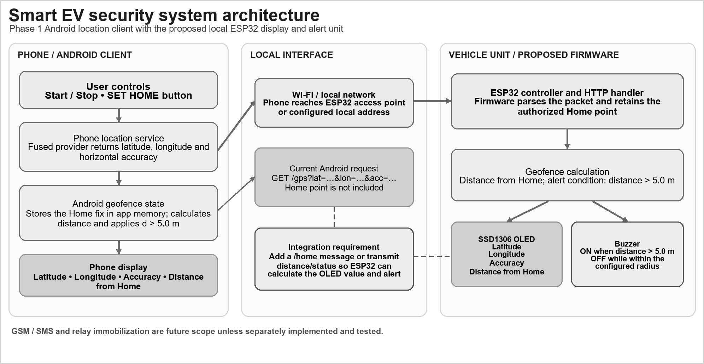
Figure 3.1: System architecture of the Android monitor and proposed ESP32 unit

The diagram separates the implemented phone path from the proposed vehicle path. The phone obtains and classifies location; the local request carries a current fix. Board-side GPS, sensor, OLED and buzzer functions remain proposed until firmware and hardware evidence are supplied.
The architecture separates the implemented phone client from the proposed vehicle controller. The current request contains the live fix but not the Home point; the device contract must transfer Home or distance/status before the ESP32 can calculate the OLED distance and buzzer condition.
The architecture has an implemented phone path and a proposed vehicle path. On the phone, the user grants foreground permission, starts location updates, saves Home and observes the calculated distance and state. A callback also constructs a GET request to the local ESP32 address. On the vehicle side, the materials describe an ESP32, a GPS receiver, movement-related sensors, an OLED and a buzzer. Until firmware is supplied, the board-side boxes represent integration requirements, not verified modules.
The interface boundary is especially important because the phone and board do not currently share all values needed by the proposed display logic. The current request contains the live coordinate and accuracy. It does not contain Home, computed distance or the phone's safe/alert state. A device-side design must either receive the Home reference and calculate its own state, or receive a versioned decision from the phone. Those alternatives have different failure and trust assumptions and should be selected before firmware is written
DATA FLOW
Each Android location callback supplies latitude, longitude and accuracy. After SET HOME, the app retains the reference in memory, calculates distance in metres, classifies the current fix using d > 5.0 m and refreshes the phone display. It then sends the current latitude, longitude and accuracy to /gps on a worker thread. The present packet does not include Home, distance or status, so the ESP32 OLED/buzzer path needs an explicit extension.
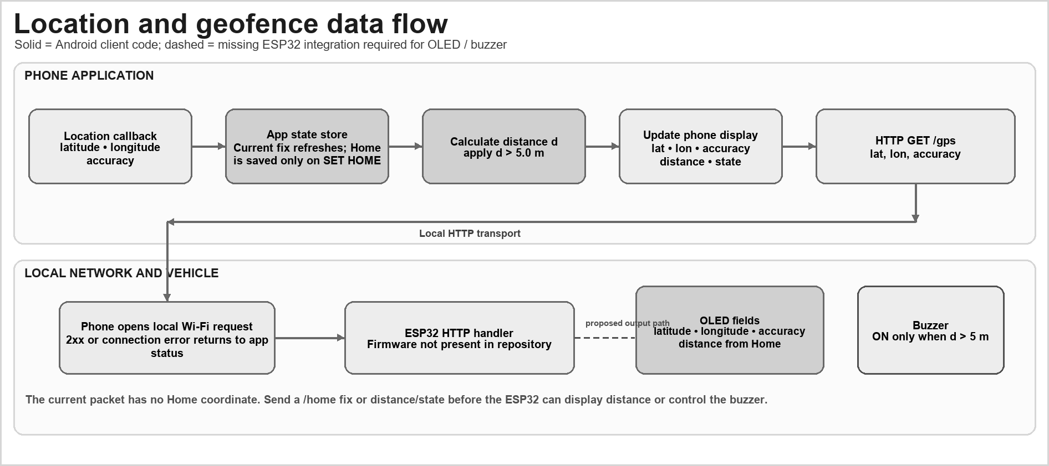
Figure 3.2: Data flow between the Android client and proposed ESP32

The upper lane shows the phone-side callback, Home state, distance rule, UI update and HTTP request. The lower lane shows the receiving endpoint and proposed outputs. The missing Home value in the present packet is identified as an integration requirement.
Each location callback is the start of a data-flow cycle. The app obtains a fix, updates the coordinate and accuracy labels, checks whether a Home value exists, calculates a distance if it does, applies the strict comparison and updates the visible state. A separate worker performs the HTTP request so that network delay does not block the UI thread. The current in-memory state is lost when the Activity is recreated unless recaptured; there is no durable database or event history shown.

SYSTEM WORKFLOW
The user grants foreground location permission and taps START. Each callback updates the current fix. If no Home point is stored, the app prompts the user to tap SET HOME and captures that fix in activity memory. Otherwise it calculates distance and evaluates the strict 5 m rule: distance at or below 5.0 m is within; a distance greater than 5.0 m is outside. The phone display and local request are updated, and the next fix repeats the check. STOP removes the location callback. ESP32 display and buzzer steps remain proposed until firmware is available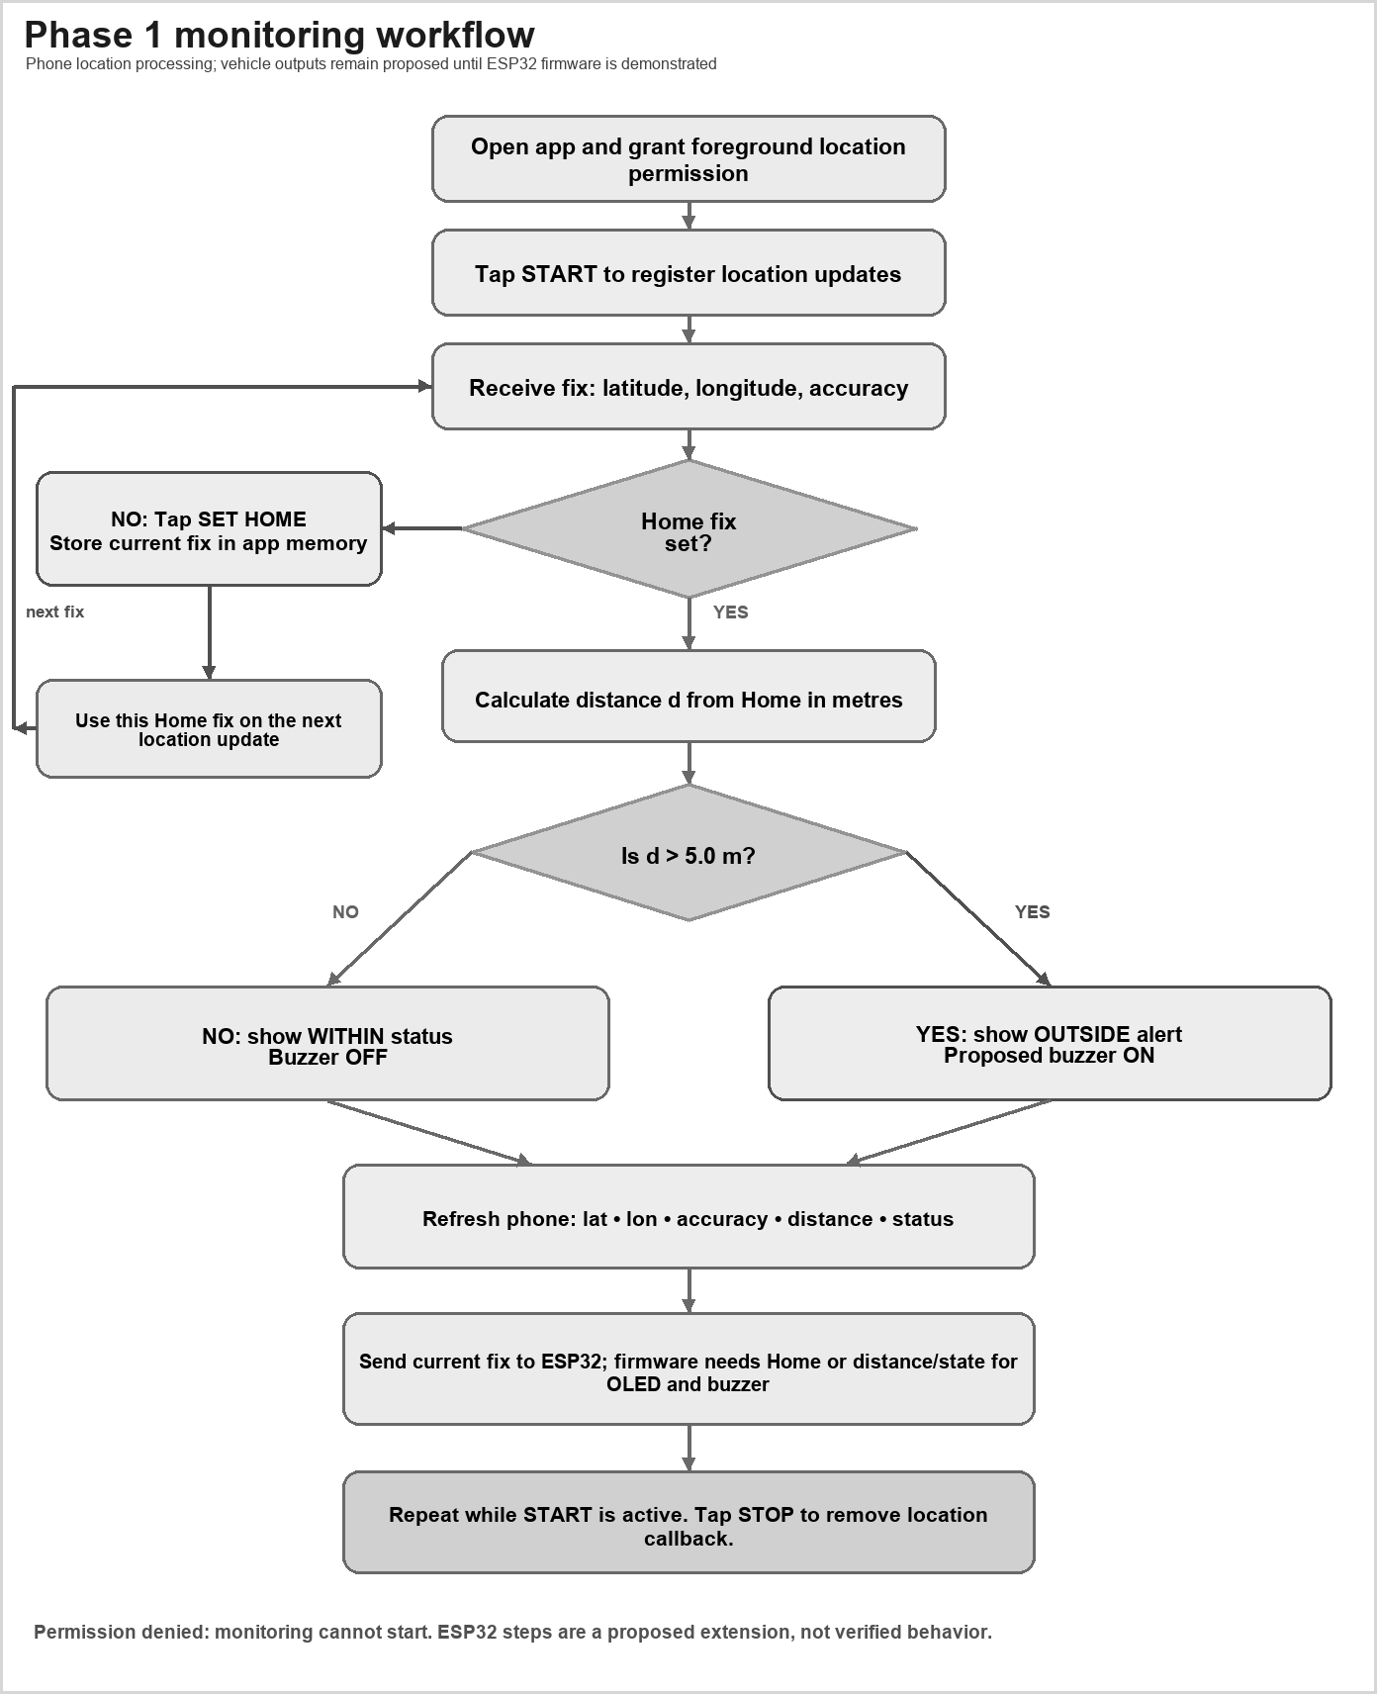
Figure 3.3: Android monitoring and proposed alert workflow
The workflow begins with a user granting permission and starting updates, then captures Home and evaluates later fixes. The decision uses the strict comparison d > 5.0 m. A proposed board alert is visually distinguished from the implemented phone state.

The workflow begins with a user decision rather than an automatic background start. Permission denial should leave the monitor stopped and provide a clear explanation. After permission is granted, Start registers the callback. The user waits for a current fix and selects Set Home. Later callbacks compare the new fix with that reference; Stop removes the callback. The supplied design uses the last known in-memory Home during that Activity session and prompts for a new reference when none is present.
A future implementation can make the workflow more robust by validating that the Home fix is recent and has usable accuracy before saving it, preserving the user's selected point across process recreation, and making the alert state resilient to short-lived boundary fluctuations. These are proposed improvements and are not represented as current behaviours
MAJOR SYSTEM MODULES

MODULE | RESPONSIBILITY | I/O
Permission | Request location. | Permission state.
Location | Register callback. | Fix and accuracy.
Home | Store point in memory. | Home coordinates.
Geofence | Distance vs 5 m. | Status.
UI | Show data and controls. | Labels/buttons.
HTTP client | Send coordinates. | HTTP status/error.
ESP32 unit | Described design. | Firmware evidence.
GSM/relay | Future remote action. | Not in reviewed app.
Table 3.1: Major modules and responsibilities
The mobile implementation can be understood as a permission and lifecycle module, a location callback module, a Home-state module, a distance classifier, a presentation layer and a local HTTP client. The repository's nested source paths were not available in the supplied files, so this report describes those logical responsibilities without assigning unverified filenames or function names. The requested source-code appendix makes this limitation explicit.
The proposed embedded modules are separate: GPS parsing, sensor acquisition, Home storage, distance calculation, display rendering and buzzer control. They require an agreed message schema and timing policy. A module should not silently infer another module's state from a stale value; timestamps, fix validity and link status should be visible in the design.

FUNCTIONAL REQUIREMENTS

ID | REQUIREMENT | INDICATOR
FR-01 | Request permission. | Runtime request.
FR-02 | Start updates. | Callback registered.
FR-03 | Show coordinate/accuracy. | UI labels.
FR-04 | Capture home point. | Memory variables.
FR-05 | Show geofence status. | 5 m comparison.
FR-06 | Stop updates. | Callback removed.
FR-07 | Attempt local send. | GET lat/lon/acc.
FR-08 | Drive OLED/buzzer. | Needs firmware proof.
Table 3.2: Functional requirements
Functional requirements are written so each can be verified by an observable action. For the current phone client, the clearest checks are whether permission is requested, callbacks begin and end, displayed values update, Home capture changes subsequent distance calculations, and HTTP status changes after a mock endpoint responds or fails. Requirements for the ESP32 display, buzzer and GSM path remain proposed until a board build is available
NON-FUNCTIONAL REQUIREMENTS

QUALITY | EXPECTATION | VERIFICATION
Usability | Clear controls/status. | User walk-through.
Location | Show accuracy. | Known reference.
Reliability | Visible errors. | Deny/no-fix/timeout.
Privacy | Stated location use. | Notice/retention.
Security | Reject unauthorized calls. | Current HTTP lacks auth.
Safety | No moving-vehicle disable. | Future bench review.
Table 3.3: Non-functional requirements
The prototype should fail visibly when a fix is missing or a request cannot be completed. It should not silently reuse a stale position as if it were current. Location data should be retained only for a stated purpose and duration, and the user should be able to stop monitoring. Any future remote command or actuator path requires stronger authentication and safety review than the current local telemetry request.

SOFTWARE AND HARDWARE REQUIREMENTS

AREA | TECHNOLOGY
Mobile | Android/Kotlin/Gradle.
Location | FusedLocationProviderClient.
Network | HttpURLConnection / GET.
Controller | ESP32 per materials; firmware absent.
Sensors | NEO-6M, PIR, QMC, OLED, button, buzzer per materials.
Future | GSM/SMS and relay not in repo.
Test tools | Phone, test site, screenshots/logs.
Table 3.4: Software requirements

ITEM | PHASE 1 REQUIREMENT / STATUS
Computer | Development computer specifications were not included in the supplied report.
Phone | Android phone shown in supplied photographs; make, model and Android version are not visible.
Board | ESP32 development board shown in supplied photographs; exact revision and firmware commit are not visible.
Prototype | Breadboard assembly with ESP32, OLED, button and buzzer shown; GY-271 raw values are visible in one OLED photo, while another photo shows GPS no fix.
Network/power | Phone screen lists EV_GEOFENCE Wi-Fi and 192.168.4.1/gps; it reports ESP32 not reachable; supply details are not visible.
Table 3.5: Hardware and demonstration requirements
The project materials identify an Android/Kotlin Gradle application and an ESP32-oriented hardware concept. The phone and board are different development targets: an Android SDK and build environment are needed for the client, while a board toolchain, firmware source, serial console and wiring record are needed for the embedded unit. The supplied materials do not state the exact computer, phone, Android version, board revision, firmware commit or IDE version, so these remain fields to complete from the actual demonstration setup.
A requirement should be recorded as a specification only when it is traceable to a source or test. The one-second desired interval, 500 ms minimum update interval, five-metre threshold and 1,500 ms HTTP timeouts are values described in the app source, not guarantees about the device's actual fix cadence or field accuracy. Hardware requirements listed in the project materials should be checked against the physically assembled prototype before purchase or test claims are made.

DATA STORAGE AND STATE
Home and last-location coordinates are activity variables; no database or durable preference storage is shown. UI values are transient. ESP32 storage cannot be described without firmware.

DATA ITEM | SOURCE | STORAGE
Current fix | Android coordinates/accuracy. | Activity/UI only.
Home point | Set Home action. | Memory variables.
Distance/state | Calculated after home. | UI text; no history.
Table 3.6: Data items and current storage behavior
The reviewed Android design keeps Home and current-location values in Activity variables and refreshes UI text. The report does not identify a database, file store or preferences layer for location history. This is a reasonable small Phase 1 state model, but it means a restart or process recreation can remove the Home reference. A future persistent store should define whether coordinates are encrypted, when they expire, how a user deletes them and whether a board retains a separate copy.

INPUT AND CONFIGURATION PROFILE

INPUT | TYPE | ROLE
Latitude | Double | Current fix.
Longitude | Double | Current fix.
Accuracy | Float, m | Displayed/sent.
Home | Nullable Double | Set Home reference.
Radius | 5.0 m | Source constant; unvalidated.
Interval | 1,000 ms | Requested.
Min interval | 500 ms | Requested.
HTTP timeout | 1,500 ms | Connect/read.
Source | Android Location | Fused provider.
Table 3.7: Location and geofence inputs
Location precision depends on settings, permission, satellite visibility and surroundings. Compare the 5 m source value with reported accuracy. Save time, source, accuracy, home/current coordinates, computed distance and observed state The input profile distinguishes the current latitude, longitude and reported accuracy from the Home coordinate and the decision radius. The accuracy field describes the provider's estimate, while the radius is the app's rule parameter; one cannot be substituted for the other. For each future trial, record the timestamp, test identifier, permission state, device, current accuracy, Home accuracy, computed distance, app state and endpoint result so that the classification can be interpreted.

APPLICATION STATE MODEL
The Android client can be described as a small stateful monitor. The states below are a design model for reviewing the supplied behavior and planning tests; labels not visible in the supplied source description should be confirmed from the app before being presented as screen text. A state change should be driven by an observable event, and a stale value should not silently appear as a fresh location.

State / event | Entry condition | Data available | Response to verify
Permission required | Foreground location permission absent or denied. | Permission result only. | Monitoring must not claim a valid current fix; show a permission explanation.
Waiting for fix | Permission granted and monitoring started; no valid callback yet. | No current coordinate. | Keep Home and distance unavailable until a valid fix arrives.
Fix available; Home unset | A current location callback has arrived. | Latitude, longitude and reported accuracy. | Display current fix; allow an explicit Home capture.
Home captured | Set Home action uses a current fix. | Home coordinate and subsequent current fix. | Calculate distance and apply the documented comparison.
HTTP request pending / failed | A request is attempted or a connection error occurs. | Current fix and local request outcome. | Expose request outcome separately from geofence state.
Stopped / Activity recreated | User stops updates or the Activity lifecycle changes. | Stored Home may be lost on recreation. | Verify callback removal and whether Home must be recaptured.
Table 3.8: Location-monitor state and proposed response

DESIGN DECISIONS AND TRADE-OFFS
The current design favors a simple foreground flow that is easy to demonstrate and inspect. That choice limits background monitoring and persistence. A very small configured radius makes the threshold easy to test with controlled coordinates but places greater importance on reported uncertainty and repeated field observations. A local HTTP request avoids a cloud dependency for a bench demonstration, while leaving authentication and receiver behavior unresolved.

Decision | Current basis | Trade-off | Evidence needed
Foreground updates | Location callback is described as started by the app. | Simple lifecycle; no verified background monitoring. | Start/stop, pause/resume and process-recreation tests.
Home held in Activity memory | No durable store is shown in the reviewed description. | Avoids persistence code; Home can be lost on recreation. | Lifecycle test and explicit persistence decision.
Decision | Current basis | Trade-off | Evidence needed
Five-metre comparison | Source-described constant and strict greater-than rule. | Deterministic software boundary; sensitive to uncertainty. | Controlled 4.9/5.0/5.1 m inputs and surveyed route.
Local HTTP GET | Documented /gps path with lat/lon/acc fields. | Simple mock-server test; no transport authentication. | Request capture, failure handling and security review.
ESP32/GSM/relay staging | Components/features appear in materials; firmware absent. | Separates concept from tested implementation. | Firmware, wiring, logs, message delivery and safety review.
Table 3.9: Design decisions and verification needs

COMPONENT BOUNDARIES AND DATA OWNERSHIP
The design contains a phone-side location client and a proposed vehicle-side controller. Assigning data ownership prevents two position sources or two independent boundary rules from silently disagreeing. The reviewed description treats the phone fix as the input to the current distance decision; the NEO-6M is named in the component plan, but no firmware establishes how its reading is used. Before integration, choose one authoritative position for each reported decision and label the source in the log.

Data / action | Current or proposed owner | Boundary that must be documented
Phone current location | Android fused-location client, as described. | Timestamp, accuracy, freshness and permission state.
Home reference | Captured in Android Activity memory in the supplied description. | Whether a future board copy is authoritative and how reset is handled.
Geofence state | Android point-distance comparison in the described Phase 1 flow. | Whether the board repeats the rule or only displays a phone decision.
Local message receipt | Proposed ESP32 receiver. | Schema, validation, acknowledgement and duplicate handling.
Sensor context | Proposed PIR and magnetic inputs. | Sampling, calibration, timestamp alignment and effect on alert state.
Table 3.10: Component boundary and data owner

CHAPTER 4 IMPLEMENTATION AND METHODOLOGY

ANDROID APPLICATION AND LOCATION ACCESS
The Kotlin app initializes FusedLocationProviderClient and requests high-accuracy updates at 1,000 ms with a 500 ms minimum. These are request settings, not guaranteed timing. Permission starts updates; Stop removes the callback.
The callback displays coordinates and accuracy. Android notes precision/frequency depend on permission and request options [2]. Denial shows a status message. No background tracking service is present in the supplied activity.
The described client uses the fused location provider to request high-priority updates with a preferred interval of 1,000 ms and a minimum interval of 500 ms. These are request preferences. Android documents that actual update timing can vary with available sources, power policy, settings and permission [2]. They should therefore be reported as configuration values rather than measured cadence.
The code requests foreground access and registers its callback when monitoring starts. When the user stops monitoring or the Activity is destroyed, the callback is removed. No background service or persistent geofence registration is shown. This behaviour supports an explicit user-controlled demonstration, but it does not establish continuous tracking when the app is not visible.

HOME LOCATION AND GEOFENCE DECISION
Set Home copies the latest fix into nullable in-memory variables. Location.distanceBetween calculates metres. Distance above GEOFENCE_RADIUS = 5.0 displays alert; otherwise the app shows safe/inside 5 m.
The threshold is not validated. There is no dwell period, entry/exit hysteresis or accuracy guard. Home is not persisted, so restart may require recapture.
Set Home copies the most recent fix into nullable latitude and longitude state. For each subsequent fix, the app calls Android's distance calculation utility and compares the result with the configured 5.0-metre constant. The comparison is strict: a distance greater than five metres produces the outside/alert state; a distance equal to or below five metres remains within. This detail is part of the source rule and should be preserved in boundary test expectations.
The implementation does not include a dwell period, hysteresis, a confidence interval or an accuracy guard. It also does not persist Home in durable storage. A future revision should make the threshold configurable and validate it against repeated known-point trials. If a dwell rule or hysteresis is introduced, the rule must be stated clearly because it changes what counts as a boundary crossing
LOCAL ESP32 TELEMETRY REQUEST
Each callback forms a request to http://192.168.4.1/gps with lat, lon and acc. A worker thread makes the HTTP GET with 1,500 ms connect/read timeouts. A 2xx response updates the phone status; errors show a connection failure. The reviewed Android code sends only the current fix. The repository does not include ESP32 server firmware, and the request does not include Home, distance or geofence state.
The request is plain HTTP and carries location in a URL. Limit it to a controlled test network. Later versions need authentication, validation, replay/rate protection and explicit acknowledgements. Do not add immobilization without safety analysis.
For the described Phase 1 phone link, the fused phone location is the authoritative source. The NEO-6M listed in project materials is a separate possible GPS source, not evidence that the Android fix is wired to that module. If both sources are used later, define source priority and handling for missing or conflicting fixes.
For each callback, the app constructs a request to the local path /gps and includes latitude, longitude and accuracy. The request runs on a worker thread and uses 1,500 ms connection and read timeouts. A 2xx response changes the displayed connection status; a failure produces an error state. These are client-side code behaviours described by the report. Without the server firmware and a matching log, they do not prove that an ESP32 accepted, parsed or acted on the values
The request uses GET and plain HTTP. Query values should be encoded and range-checked by both sender and receiver; repeated callbacks can create a high request rate if the endpoint is slow. A production-oriented interface should use an authenticated method, explicit message version, timestamp or sequence number, response body, rate limit and clear handling for retryable versus permanent errors.

PROPOSED PHONE TO ESP32 LINK
Proposed link contract: when the user taps SET HOME, the phone sends the saved Home latitude, longitude and accuracy to an ESP32 /home handler. Each later location callback sends current latitude, longitude and accuracy to /gps. The ESP32 retains the Home reference, calculates distance, applies d > 5.0 m, and updates the SSD1306 OLED with latitude, longitude, accuracy and distance from Home. The buzzer turns on only when the distance exceeds 5 m. The /home handler, ESP32 parser, OLED and buzzer firmware are not present in the reviewed repository; these outputs are a proposed design, not a verified result
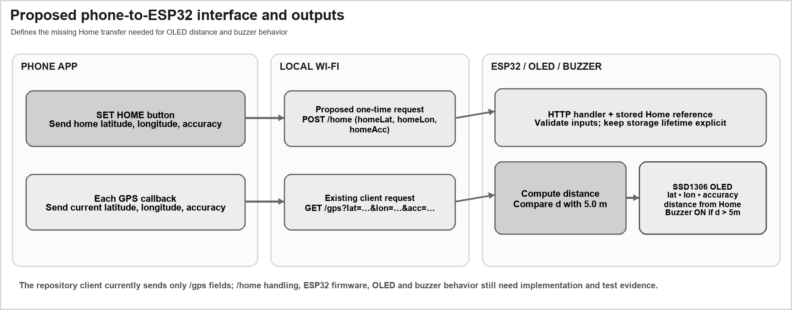
Figure 4.1: Proposed phone-to-ESP32 Home and GPS message paths
The proposed design separates Home registration from current-location telemetry. This allows the board to retain a reference, but the endpoint handlers and response schema are not present in the reviewed source snapshot.

Before implementation, specify the /home and /gps request fields, response codes, timeout behavior, Home storage lifetime and input validation. Record the ESP32 firmware version, network setup, OLED fields and buzzer rule. Demonstrate inside, boundary and outside cases with matching phone screenshots, serial logs and OLED/buzzer evidence.
The proposed link adds a Home-setting operation and keeps the live position operation separate. A Home request would send the chosen reference coordinate and accuracy; a GPS request would send the current fix and timestamp. If the board calculates the distance, it should return the computed state and the Home revision it used. If the phone calculates the state, the request should include the decision and the board should display it as phone-originated rather than independently validated.
The interface needs a documented schema before the mobile client and firmware can be integrated. It should define coordinate units and precision, valid numeric ranges, request IDs, versioning, response codes, timeout behaviour, stale-fix rejection and what happens when Home is missing. The proposal in Appendix C is a design worksheet; it is not evidence of a server implementation.

GSM ALERT AND REMOTE CONTROL BOUNDARY
The conference paper proposes GSM SMS and relay immobilization [1]; neither appears in the reviewed app repository. No SIM800L code, authentication, SMS log, relay schematic or controlled test was supplied. They remain future scope.
Any relay must avoid disabling a moving vehicle and use fail-safe behavior, isolation, access control and supervised bench testing. SMS commands need sender verification and replay protection.
GSM alerting is a separate subsystem from the local Wi-Fi request. Before it can be reported as implemented, the project needs source code, modem wiring, SIM/network status, recipient configuration and a dated sent/received message record. A delivery failure must not be presented as a successful alert simply because a command was issued to a modem.
Remote immobilization has safety implications that are absent from the current app. Any future relay must be evaluated on a bench with a controlled load, a fail-safe state, isolation and a rule that prevents disabling a moving vehicle. SMS or network commands must be authenticated, protected against replay and logged. The current Phase 1 report does not claim remote control.

IMPLEMENTATION FLOW
The app requests permission, starts updates, renders each fix, checks for home, calculates distance, updates status and attempts HTTP. Stop unregisters the callback; activity destruction calls stop. Server behavior and persistence are undocumented.
Open questions include authoritative position source, ESP32 reliability, sensor contribution and location uncertainty at the selected radius.
The implementation flow begins when the user grants location access and taps Start. The app registers a location callback; each callback updates the current values and, if Home is available, computes distance and status. A separate network worker sends the current fix. Stop removes the callback, and Activity destruction also stops it. This order helps isolate client-side UI responsiveness from network timing.
The code should be tested at the transition points in this flow: permission denial, permission grant, no fix, first fix without Home, Home capture, subsequent inside/outside samples, stop, Activity recreation and request failure. The expected states are described in the test matrix; actual outcomes remain unrecorded until a test run is saved

EVENT AND DATA RECORDING
The activity updates UI but does not save history. Record timestamp, test ID, source, home/current coordinates, accuracy, distance, HTTP result and actual status in a separate sheet. Protect location data and disclose storage.
Persistent history, cloud telemetry and multiple zones require retention, authentication and deletion rules.
The app updates the display but does not show a durable event history in the supplied implementation. For a repeatable evaluation, the team can keep a separate test log containing an anonymous test ID, timestamp, measurement method, fix values, accuracy estimates, calculated distance, UI state and HTTP response. Exact location data should be protected because a home coordinate is sensitive even in a classroom prototype.

SECURITY, PRIVACY AND INPUT HANDLING
The app requests foreground location and sends data to a local endpoint. Explain when monitoring is active and allow stop. Current HTTP is unencrypted/unauthenticated, unsuitable for untrusted networks or remote control. No security audit is claimed The application requests access to location and transmits location values to a local endpoint. A clear explanation should state when monitoring begins, what is sent and how to stop it. The reviewed HTTP request is unauthenticated and unencrypted; it should remain on an isolated demonstration network and should not be used for remote control. No security audit or penetration test is claimed.
The receiver should reject missing, non-finite and out-of-range coordinates, stale timestamps and malformed requests. The client should handle timeouts without blocking the interface, avoid displaying stale success after a newer failure, and avoid sending more requests than the board can process. A future design should provide an explicit acknowledgement that identifies the received message, rather than relying only on a generic 2xx status.

IMPLEMENTATION LIMITS AND COMPLETION EVIDENCE
Repository has Android code and Gradle files, not ESP32 firmware. Add build/install record, phone model/Android version, permission screenshots, location log, firmware response, wiring photo and controlled buzzer/OLED evidence.

IMPLEMENTATION SUMMARY

AREA | PRESENT | REMAINING
Location | Callback and labels. | Attach screenshot.
Home | Manual capture. | Test restart.
Geofence | 5 m comparison. | Known-distance trials.
Device link | HTTP client code. | ESP32 response log.
Sensor concept | Parts in materials. | Wiring/firmware evidence.
GSM/relay | Future only. | No code evidence.
Table 4.1: Implementation evidence summary

LOCATION DECISION SEQUENCE
The implementation sequence described by the report can be reviewed as a deterministic transformation from a provider callback to a visible status. It begins with a valid location object, reads the current coordinate and reported accuracy, updates the interface, checks whether a Home reference is present, computes the separation in metres, and evaluates the configured comparison. The reported accuracy is displayed and sent with the fix, but the described decision does not combine accuracy with the 5.0 m threshold. That difference should remain visible in the test record.

Input / condition | Processing described | Expected verification
No permission | Updates should not be treated as available. | Denied-permission test; record exact interface response.
No valid fix | Home/distance calculation cannot be completed. | No-fix test; stale values should be distinguishable from a current fix.
Home is null | Show current location without computing a Home distance. | Set Home only after a valid fix; capture before/after values.
Distance below 5.0 m | The strict d > 5.0 m condition is false. | Deterministic input at 4.9 m.
Input / condition | Processing described | Expected verification
Distance exactly 5.0 m | The strict d > 5.0 m condition is false. | Exact boundary input and displayed state.
Distance above 5.0 m | The strict d > 5.0 m condition is true. | Deterministic input at 5.1 m.
Poor reported accuracy | Value is shown/sent; no accuracy guard is described. | Record accuracy and classification; do not label as validated crossing.
Table 4.2: Location decision inputs and edge cases

LOCATION LIFECYCLE AND CALLBACK MANAGEMENT
The request interval of 1,000 ms and minimum interval of 500 ms are location-request parameters, not guarantees that a callback will arrive at those exact rates. Provider behavior depends on permission, device settings, operating conditions and other factors described in Android's location guidance [2], [3]. Testing should record actual timestamps and visible freshness. Start and stop operations should be paired with callback registration and removal; lifecycle recreation should be checked because the Home values are described as Activity-memory variables.
A robust implementation review should also distinguish a missing fix from a stale last-known display, and should ensure asynchronous UI updates are dispatched safely to the interface thread. The available report describes a worker thread for HTTP, but it does not supply the Kotlin source needed to verify cancellation, lifecycle ownership or callback cleanup. These points are therefore review criteria rather than claims about the code. LOCAL REQUEST VALIDATION AND FAILURE REPORTING
The described request is an HTTP GET to the private-network address 192.168.4.1 at the
/gps path, with latitude, longitude and accuracy query values. The connect and read timeouts are each set to 1,500 ms, and the request runs on a worker thread. A request attempt, an HTTP response and a physical board action are three different events; the app should present them separately so a refused connection cannot be mistaken for a successful security alert.
Validation should cover finite numeric values, latitude and longitude ranges, non-negative accuracy and URL encoding. The receiver should define how it handles missing parameters, repeated samples, stale timestamps and unknown fields. Because location appears in a URL and plain HTTP does not authenticate the sender, use test coordinates on an isolated network and avoid real residence data in ordinary logs. A later interface can use a versioned structured request and explicit acknowledgement, but that would be a change to the documented Phase 1 contract rather than a verified current feature.

Outcome | Client-visible distinction | Diagnostic record
Request not started | No request attempt was made. | Reason, app state and test identifier.
Connection refused / unreachable | Receiver did not return an HTTP response. | Address, elapsed time, exception category and network state.
Timeout | No complete response arrived within the configured limit. | Start time, timeout, endpoint and client status.
HTTP non-2xx | A response arrived but was not accepted as success. | Status code and sanitized response text.
HTTP 2xx | Server acknowledged the request at the protocol layer. | Matched server log and response body; does not alone prove sensor or actuator behavior.
Table 4.3: Local request outcome and diagnostic record

CHAPTER 5 RESULTS AND DISCUSSION
  - EVALUATION METHOD
Test build and permission behavior, location display, home capture, boundary status and start/stop. Test endpoint with mock server, then ESP32 if available. Save device/site and raw observations; this plan is not a completed test record.
The supplied paper contains claims for GPS error, geofence accuracy, GSM timing, response time and power [1]. Raw datasets and instrumentation logs were not included, so those claims are not used as measurements in this report.
Evaluation should proceed in layers. First, build and launch the Android app and record the device and Android version. Second, test permission and lifecycle behaviour. Third, verify the distance comparison with simulated or independently surveyed points, including values just below, equal to and just above the threshold. Fourth, use a mock local endpoint to test success, timeout and malformed-response handling. Only after these stages should the project connect an ESP32 and compare phone state, server logs, display and buzzer output.
The supplied files contain no dated execution log, independently surveyed reference or raw field-trial dataset. This report separates source-described behavior, undated photographs and generated examples; it does not claim measured accuracy, latency, reliability, energy use or classification performance.
  - TEST CONFIGURATION AND MEASUREMENTS

ITEM | VALUE | NOTE
Radius | 5.0 m | Configured comparison value; not a validated accuracy bound.
Requested interval | 1,000 ms | Source setting; not a measured callback cadence.
Minimum interval | 500 ms | Source setting; provider timing can vary.
HTTP timeout | 1,500 ms | Source setting; no dated receiver log supplied.
Trials | 6 generated boundary examples and 10 generated sample rows | Illustrative values; the app photograph is undated.
Accuracy/latency | Generated estimates range from 2.8 m to 5.2 m; latency was not measured. | No surveyed error or transition-time result is claimed.
Table 5.1: Test configuration and evidence to capture
The source configuration lists a preferred location interval of 1,000 ms, a minimum interval of 500 ms, a radius of 5.0 m and connection/read timeouts of 1,500 ms. The test record should distinguish these constants from measured outcomes. A measured update interval is computed from callback timestamps; a measured alert delay is the difference between a reference boundary crossing and the displayed or audible event; an HTTP success rate is counted from responses over a stated number of requests.

  - RESULTS RECORD
No dated execution log or independently surveyed trial dataset was included. Table 5.2 is populated with generated examples to show how the strict comparison behaves; the values are not GPS measurements, accuracy results, latency results or security validation. An undated phone photo is described separately in Chapter 6.
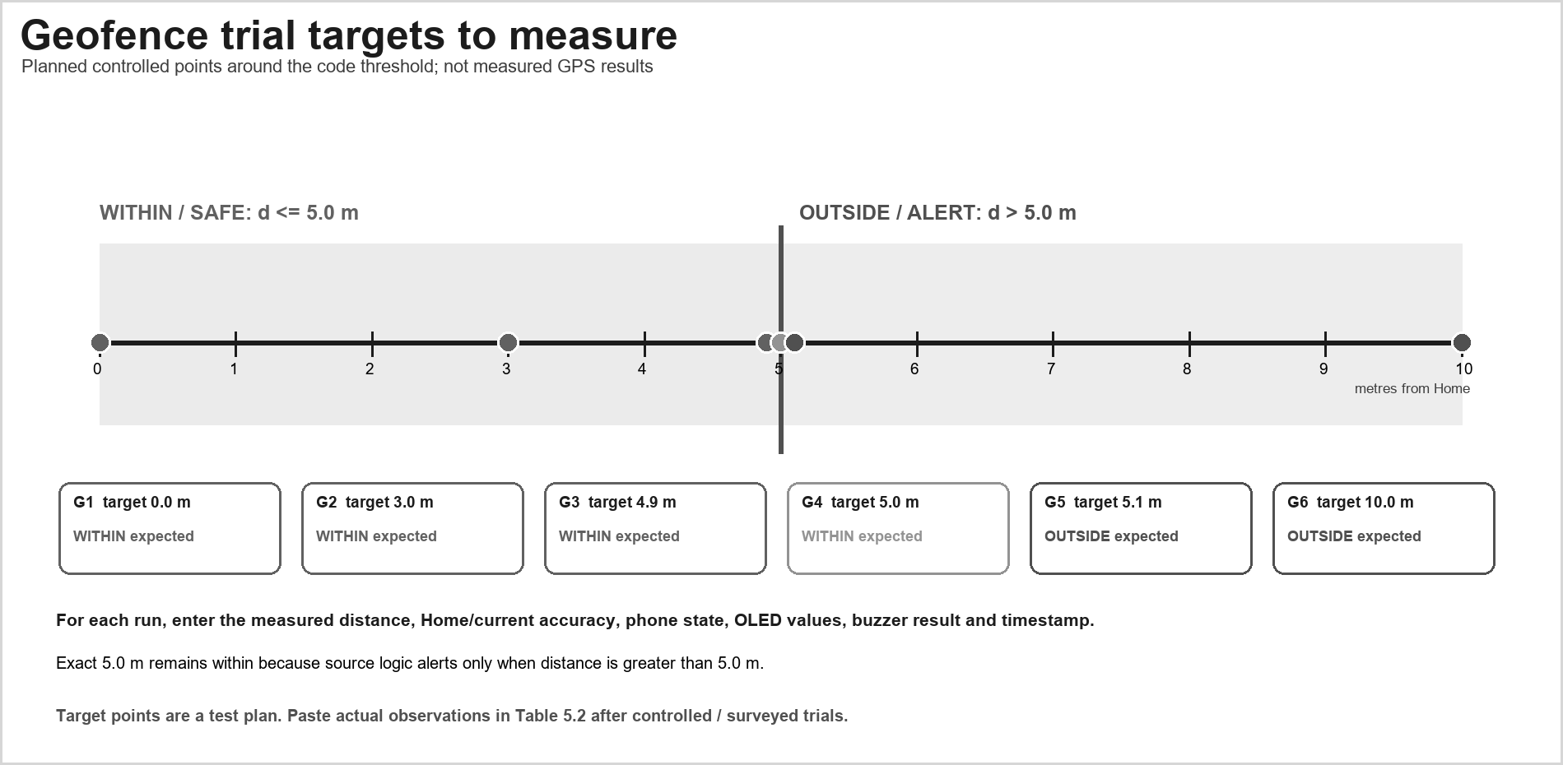
Figure 5.1: Planned geofence trial targets (not measured results)
The target points bracket the configured five-metre threshold. The labels show expected software classifications only; the figure contains no measured GPS values or observed outcomes.
For every trial, record the independently established target position, app-calculated distance, Home-fix accuracy, current-fix accuracy, phone state, OLED latitude/longitude/accuracy/distance, buzzer state, timestamp and HTTP response. Keep the screenshot or serial log. The six target points in the figure are a repeatable test plan, not observations; the expected software state follows the current strict comparison d > 5.0 m.

TRIAL / TARGET | EXPECTED CODE STATE | SIMULATED VALUES AND EVIDENCE
G1 / 0.0 m | Within (d <= 5.0 m) | Generated: d=0.4 m; Home/current accuracy=3.5/2.8 m; 28 Sep 2026 10:02 IST; SYN-01.
G2 / 3.0 m | Within (d <= 5.0 m) | Generated: d=3.2 m; Home/current accuracy=3.5/3.3 m; 29 Sep 2026 10:05 IST; SYN-02.
G3 / 4.9 m | Within (d <= 5.0 m) | Generated: d=4.8 m; Home/current accuracy=4.1/4.4 m; 30 Sep 2026 11:15 IST; SYN-03.

TRIAL / TARGET | EXPECTED CODE STATE | SIMULATED VALUES AND EVIDENCE
G4 / 5.0 m | Within at boundary (d > 5.0 m is false) | Generated: d=5.0 m; Home/current accuracy=4.8/4.1 m; 02 Oct 2026 10:20 IST; SYN-04.
G5 / 5.1 m | Outside alert (d > 5.0 m) | Generated: d=5.2 m; Home/current accuracy=4.3/4.0 m; 08 Oct 2026 09:48 IST; SYN-05.
G6 / 10.0 m | Outside alert (d > 5.0 m) | Generated: d=9.7 m; Home/current accuracy=3.9/4.5 m; 20 Oct 2026 16:15 IST; SYN-06.
Table 5.2: Simulated geofence decision examples, not field measurements
The six rows in Table 5.2 use generated distances close to the planned inputs of 0.0, 3.0, 4.9, 5.0, 5.1 and 10.0 m. They follow the app rule: distances at or below 5.0 m classify within, while values above 5.0 m classify outside. Their dates fall between 28 September and 20 October 2026; they are illustrative, not observed trial results.
A genuine result record should include the independent reference method, phone model and operating-system version, permission mode, location settings, site conditions, number of repeats, Home and current accuracy estimates, callback interval, distance output, displayed state and endpoint or board response. The generated examples do not supply those measurements.
  - LOCATION UNCERTAINTY AND THRESHOLD
The 5.0 m value is the configured decision threshold, not the GPS accuracy. Android reports horizontal accuracy as an estimated radius at the 68% confidence level [8]; it is not a guaranteed error bound. Record both the Home-fix and current-fix accuracy with each distance. When the reported uncertainty overlaps the 5 m boundary, a single classification may be unstable. Repeat surveyed inside, boundary and outside trials, then assess false alerts and missed crossings before selecting any filter, hysteresis or dwell rule. The current code has no accuracy guard, hysteresis or dwell period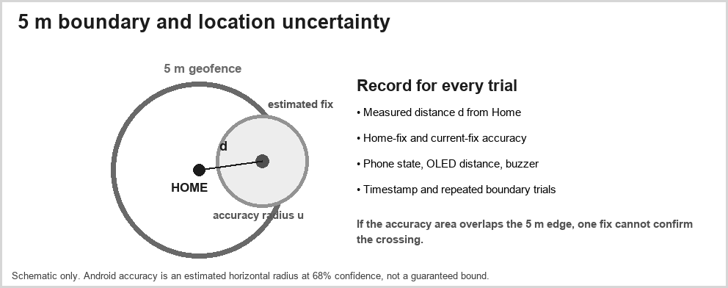
Figure 5.2: Five-metre boundary and reported location uncertainty

.
The accuracy estimate reported by Android is not a guaranteed bound. Android documents the value returned by Location.getAccuracy as an estimated horizontal accuracy radius at 68% confidence [8]. If the reported uncertainty is similar to or larger than the configured five-metre rule, a binary point comparison may be unstable near the boundary. The user interface should avoid implying centimetre-level certainty from a five-metre code constant.
A future threshold study should use surveyed points and repeated measurements on the intended device. Record the distributions of observed distances and accuracy values for known positions inside, near and outside the boundary. Then compare candidate radii and optional hysteresis or dwell policies using false-alert and missed-crossing counts. These measurements are needed before selecting a production threshold.
  - PERFORMANCE METRICS TO REPORT
Report observed update interval, median/max boundary-to-alert delay, correctly classified inside/outside fraction and HTTP success rate. Include sample count and conditions. Measure energy only with a stated method. GSM/relay timing is not applicable before implementation.
Performance reporting should name each metric, its numerator and denominator, the number of trials and the measurement method. Useful measures include median and maximum callback interval, boundary-to-alert delay, proportion of correct inside/outside classifications, HTTP acknowledgement rate, request timeout count and energy change under a defined instrumented workload. A percentage without a sample count or a timing value without a start and end event is not reproducible
FUNCTIONAL TEST PLAN

TEST CASE | EXPECTED | ACTUAL STATUS
Install/open app. | App opens; record device/build. | App screen photo supplied; build and capture date are not visible.
Deny permission. | Monitoring does not start. | No permission-denial evidence supplied; live outcome not recorded.
Grant/start. | Location values appear. | Undated photo shows latitude 13.0931288, longitude 80.7180467 and 3.4 m reported accuracy.
Set Home. | Current fix is reference. | Photo reports 3.1 m from Home; Home coordinate and capture time are not visible.
Point inside 5 m. | Safe status. | Photo displays SAFE inside 5 m at 3.1 m; no surveyed reference is supplied.
Point outside 5 m. | Geofence alert. | Generated example at 5.2 m classifies outside; no live outside trial is documented.
Stop. | Callback removed. | Separate supplied screenshot shows GPS STOPPED; no callback lifecycle log is supplied.
ESP32 reachable. | 2xx GPS sent status. | No; the app photo reports ESP32 NOT REACHABLE.
ESP32 unavailable. | Error shown. | The app photo reports NOT REACHABLE; HTTP status and receiver log are unavailable.
Restart after home. | Record persistence behavior. | No restart observation is included in the supplied evidence.
Table 5.3: Functional and integration test matrix

Functional tests should record both expected and actual outcomes. A permission-denial test should confirm that monitoring does not start; a Home test should verify which fix was stored; boundary tests should check below/equal/above comparisons; a stop test should check that callbacks cease; and endpoint tests should cover success and failure. Hardware cases should be marked not applicable until the firmware and board are present.
  - LIMITATIONS AND VALIDITY THREATS
- Repository provides Android client, not ESP32 firmware or full embedded implementation.
- Home point is held in activity memory; lifecycle persistence needs testing.
- The 5 m radius may be smaller than location uncertainty.
- Update requests do not guarantee actual provider timing.
- HTTP is unauthenticated/unencrypted and unsuitable for untrusted networks or control.
- GSM, relay, ignition, cloud, power and field performance are unverified.
- No raw test log, surveyed reference, device model or Android version was supplied.
- Prototype demonstration does not establish vehicle-grade security or roadworthiness.
The strongest current limitation is evidence coverage: the app logic is described, but there are no supplied runtime screenshots, phone specifications, test logs, firmware, wiring photographs or raw measurements. A report built from source inspection cannot establish behaviour under poor satellite visibility, battery restrictions, network loss or Activity recreation. It also cannot show that a board or a relay was physically assembled.
The fixed radius and requested intervals are code settings rather than validated performance. The local GET request has no authentication. The distinction between phone location and the NEO-6M module must remain clear. These limitations constrain the conclusions to a Phase 1 implementation and design review.

METRICS AND ANALYSIS RULES
The project has no supplied measured dataset. The following definitions are provided so that later results use a stated denominator and do not confuse a provider estimate with ground truth. Classify each independent location sample against a site label established before the app result is observed. Preserve raw timestamps and all valid and invalid samples, and report how many callbacks or visits contributed to each summary.

Metric | Calculation / record | Interpretation limit
Position error | Distance between the phone-reported fix and an independent surveyed coordinate. | Not the same as the  provider-reported accuracy value.
False-outside rate | Known-inside samples shown outside / all known-inside samples. | A sample-based rate; repeated callbacks at one point are correlated.
Missed-outside rate | Known-outside samples shown within / all known-outside samples. | Requires pre-labelled outside points and a complete denominator.
Transition delay | App transition time minus independently observed crossing time. | Requires a consistent clock and defined first-transition rule.
HTTP success rate | Matched valid responses / total requests sent. | A client attempt without a receiver response is not a success.
Power use | Measured change over a stated duration and device state. | No current, battery or energy measurements are supplied.
Table 5.4: Evaluation metrics and interpretation

RESULTS STATUS AND EVIDENCE INTERPRETATION
The available evidence supports a source-level account of the Android workflow and the intended architecture. It does not support a field-performance conclusion. A final results section should distinguish code inspection, a functional run, a board integration run and a repeated outdoor evaluation because each has a different unit of evidence. The table below records that distinction for the artifacts available during this report build.

Evidence item | What it can support | What it cannot support | Current status
Project report and diagrams | Describe intended modules, data path and test plan. | Prove that the phone, ESP32 or sensors executed together. | Supplied.
Android source description | Identify request interval, Home capture, distance rule and request fields as reported. | Prove runtime success or boundary accuracy. | Reported; source files not reviewed.
Public repository root listing | Confirm an Android Gradle repository and root entries. | Identify nested source files or verify code excerpts. | Root-level information only.
Dated app screenshot / logs | Show a specific build and observed UI state. | Establish broad accuracy or reliability from one image. | Undated app photographs supplied; no build or capture-date log.
Repeated field record | Support sample-level error and transition analysis. | Guarantee future or all-site performance. | Not supplied.
Firmware, wiring and matched serial log | Support a specific board integration observation. | Establish GSM or relay behavior without separate evidence. | Breadboard and OLED photographs supplied; firmware commit, wiring map and serial log are not supplied.
Table 5.5: Evidence available and claim boundary

CHAPTER 6
APPLICATION INTERFACE AND DEMONSTRATION

  - ANDROID APPLICATION RESULT

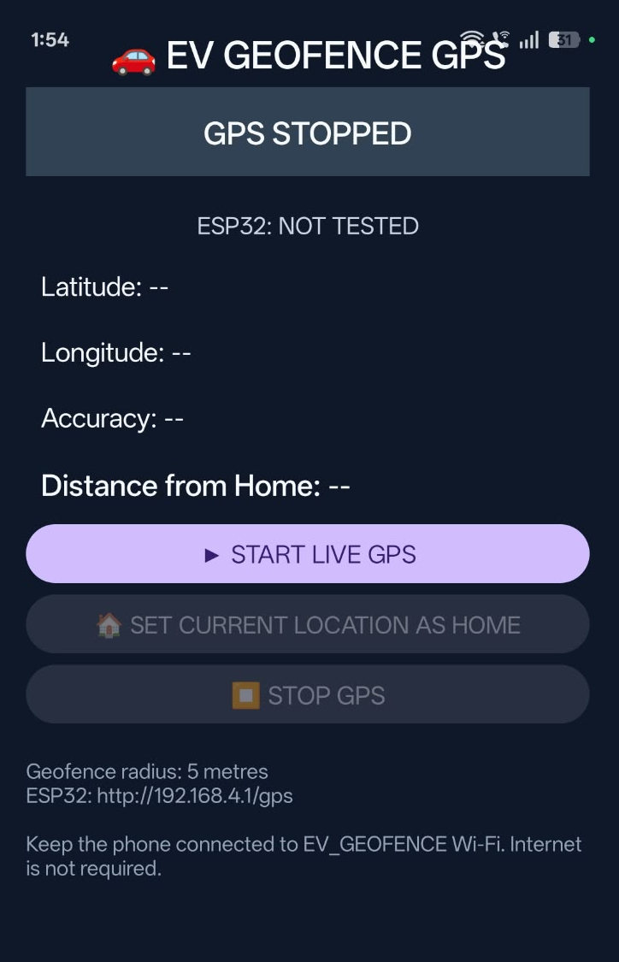

Figure 6.1: Android application screenshot placeholder
Replace the outlined panel with a screenshot from the installed project build. The evidence should show the actual controls and values and identify the device and Android version.
The documented interface has Start, Set Home and Stop controls and displays the current coordinate, reported accuracy, distance, geofence state and ESP32 request status. The screenshot panel in this report is deliberately a placeholder because no installed-app screenshot was supplied. A final demonstration image should show the actual build and include the phone model, Android version and permission mode in its caption or accompanying note.
During a demonstration, the operator should first explain the permission prompt, wait for a valid current fix, select Home, and then move to a known test point. The displayed distance and state should be read together with the accuracy value. The demonstration should not claim background monitoring because the reviewed app is described as foreground-only

6.2 INSIDE/OUTSIDE GEOFENCE TRIAL EVIDENCE PLACEHOLDER

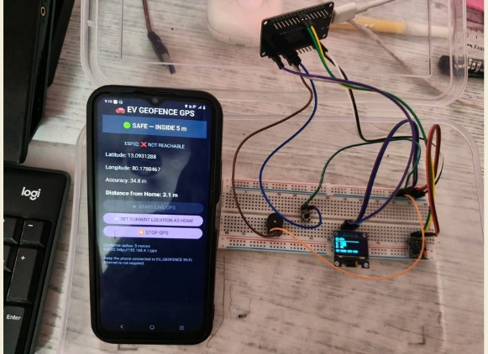

Figure 6.2: Inside/outside geofence trial evidence placeholder

Insert genuine screenshots or a dated trial log showing the reference method, reported accuracy, computed distance and actual displayed state. Do not use the target distances from Figure 5.1 as observations.
A valid inside/outside demonstration needs a known reference point and an independent method for establishing the target distance. The screenshot or log should preserve the Home fix, current fix, accuracy estimates, computed distance, displayed state and time. A test at the exact threshold is useful because it confirms the strict greater-than rule, but it should not be treated as a field-accuracy measurement.
.

6.3 ESP32 HARDWARE RESULT

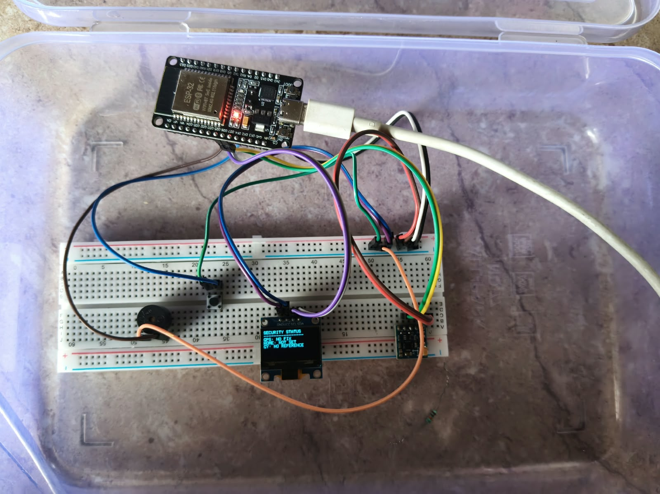

Figure 6.3: ESP32 prototype and wiring evidence placeholder

Insert a photograph of the physical assembly only after it is built. Identify the board, firmware commit, wiring and connected components so that a design drawing is not mistaken for hardware evidence.
The project materials name the controller and sensor/display components but do not include verified assembly evidence in the reviewed report. The panel is reserved for a photograph of the actual board and wiring, accompanied by the board revision, firmware commit, pin map and supply conditions. A conceptual diagram or parts list is not a substitute for an assembled prototype.

  - COMMUNICATION AND ALERT RESULT

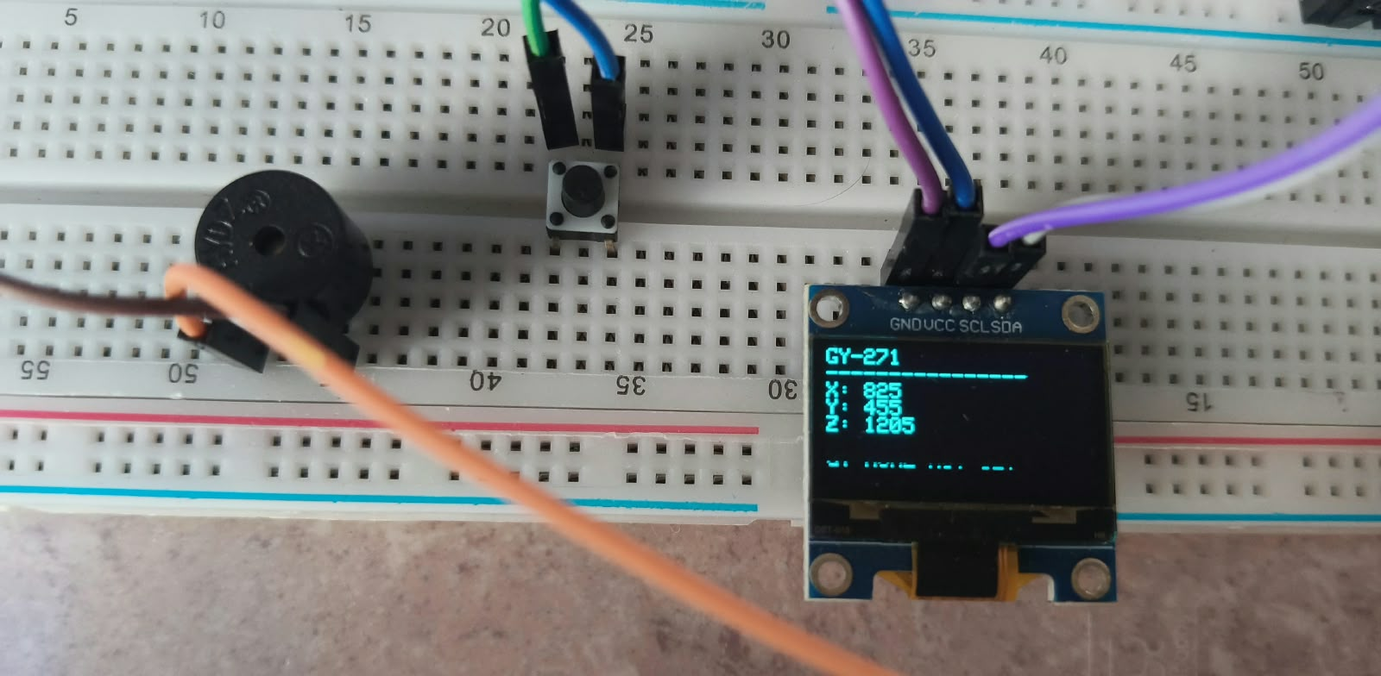
Figure 6.3: OLED screen displaying GY-271 raw axis values

The supplied OLED photo displays GY-271 raw values X=825, Y=455 and Z=1205. The image does not show units, calibration, firmware revision or a matched phone request.
The available phone photo reports ESP32 NOT REACHABLE. The OLED photos show a GPS no-fix state and a separate GY-271 screen with X=825, Y=455 and Z=1205. No matched HTTP response, serial record, buzzer event or GSM delivery record was supplied.

  - CONFIGURATION USED FOR A TRIAL
Source settings: 1,000 ms requested interval, 500 ms minimum, 5.0 m radius and 1,500 ms HTTP timeouts. These are code values, not observed performance.
Radius | 5.0 | m; source setting.
Update interval | 1,000 | ms; requested interval, not observed cadence.
Minimum interval | 500 | ms; source setting.
Connect timeout | 1,500 | ms; source setting.
Read timeout | 1,500 | ms; source setting.
Phone | Android phone visible in supplied photos; model not readable. | Photo evidence is undated.
Android | Version and permission mode are not visible. | Not inferred from the interface image.
Test site/date | Undated photo shows 13.0931288, 80.7180467, accuracy 3.4 m and distance 3.1 m; generated examples are dated 28 Sep to 20 Oct 2026. | The photo does not show its capture date or independent reference method.
Table 6.1: Phase 1 configuration and field values
The supplied images show separate app and OLED states, but no shared test identifier or timestamp links them into one end-to-end run.
The configuration values are source settings: 1,000 ms requested interval, 500 ms minimum interval, 5.0 m radius and 1,500 ms HTTP timeouts. The app photo shows a 3.1 m distance and 3.4 m reported accuracy, but its device, site and capture date are not visible. Generated samples use dates between 28 September and 20 October 2026.
  - OBJECTIVE ACHIEVEMENT AND DISCUSSION
OBJECTIVE | EVIDENCE | GAP
Live location | Source-described callback; undated phone photo shows a coordinate and 3.4 m accuracy. | Capture date, device model and callback log are unavailable.
Home/distance | Undated phone photo shows 3.1 m from Home. | Home coordinate and independent reference are unavailable.
Geofence | Photo screen reports SAFE inside 5 m; generated examples show the 5.0 m rule. | No surveyed boundary trial is supplied.
ESP32 send | Phone photo reports ESP32 NOT REACHABLE. | No successful receiver response or serial log is supplied.
Hardware/remote | Design in supplied materials. | Proof; GSM future.
Table 6.2: Phase 1 objective alignment
Android code supports foreground location, Home capture, distance status and a local HTTP attempt. Supplied photos show one app reading and an ESP32 breadboard with OLED output; they do not include a dated matched receiver log. GSM and immobilization remain future work
The mobile objectives are supported at source level, and supplied photographs show a 3.1 m app distance and prototype OLED states. The images do not verify measured field performance, calibrated sensor behavior, matched phone-to-board communication, GSM, remote control or actuator operation.
  - APPLICATION WORKFLOW AND OBSERVABLE OUTPUTS
The supplied phone photo shows Start, Set Home and Stop controls and a location state reporting 13.0931288, 80.7180467, 3.4 m accuracy and 3.1 m from Home. The capture date, phone model and independent reference method are not visible.
User action / event | Input | Output to observe | Evidence to capture
Grant or deny location access | Android permission result. | Monitoring permitted or blocked state. | Permission dialog outcome and app status.
Start monitoring | Location provider callbacks. | Current latitude/longitude and accuracy when available. | Screen plus timestamped callback record.
Set Home | Current valid fix. | Saved Home coordinate or explicit inability to capture. | Current fix and Home values in the same run.
Observe boundary state | Home, current fix and computed distance. | Within/outside classification using the 5.0 m rule. | Controlled point label, distance, accuracy and screen.
Send local request | Current latitude, longitude and accuracy. | HTTP response or visible failure state. | Phone status matched with server/board log.
Stop / recreate Activity | User action or lifecycle event. | Callbacks cease; Home persistence behavior is visible. | Before/after state and callback timestamps.
Table 6.3: Application inputs, displayed outputs and evidence
During a demonstration, distinguish the phone-side reading from the receiver result. The supplied app photo reports ESP32 NOT REACHABLE, so it does not prove that a board processed the request. The generated boundary examples in Chapter 5 are clearly identified as simulated
CHAPTER 7 CONCLUSION AND FUTURE WORK
  - CONCLUSION
Phase 1 documents an EV security prototype centered on location and geofence status. Android requests foreground updates, stores a home point in memory, calculates distance, compares it with a 5 m constant and displays safe/alert state. It attempts to send location to a local ESP32 URL.
Slides and README describe ESP32, GPS, motion/magnetic sensors, OLED and buzzer, but the repository snapshot lacks firmware and hardware test evidence. GSM, cloud tracking and relay immobilization are proposed extensions, not verified functions.
The project establishes an app workflow and integration boundary. Performance conclusions depend on device tests, uncertainty analysis and hardware evidence. Describe it as a Phase 1 prototype/design until verified.
Phase 1 establishes a phone-side location-monitoring workflow and an explicit local-device integration boundary. The current design obtains foreground fixes, captures a Home point in Activity memory, computes distance, applies a 5.0-metre comparison and attempts to send the current fix to a local endpoint. These are source-described behaviours, not independently measured field outcomes.
The report does not claim a working GSM alert, ESP32 firmware, OLED/buzzer response, relay control, GPS accuracy, latency, power result or commercial theft-prevention performance. Those claims require dated implementation evidence. The most important next step is to create a repeatable end-to-end demonstration with the phone, board, firmware, interface and raw test log under one versioned setup.
  - PHASE 2 SCOPE

WORK PACKAGE | ACTIVITIES | ACCEPTANCE EVIDENCE
Android | Build, lifecycle, persist home. | Versioned build/screenshots.
ESP32 firmware | Endpoint and sensor logic. | Source, wiring, upload log.
Geofence test | Surveyed repeated trials. | Raw measurements.
Protocol security | Auth, validation, replay protection. | Threat review/negative tests.
GSM | SMS and recipient configuration. | Sent/received log.
Relay safety | Bench-only fail-safe design. | Approved schematic/test.
System evaluation | Latency, alerts, energy. | Reproducible method/raw data
Table 7.1: Phase 2 development roadmap
Phase 2 can be organized around staged acceptance evidence: source and wiring for the ESP32 endpoint; persistent and lifecycle-safe Home state; surveyed geofence trials; authenticated communication; verified local alerts; and a safety-reviewed relay test on a bench. Each work package should have a named owner, repository commit and acceptance artifact
7.3 FUTURE RESEARCH
- Add durable home/geofence storage and lifecycle-safe tracking with clear privacy controls.
- Validate a configurable radius through repeated surveyed trials.
- Publish ESP32 firmware, wiring, calibration and endpoint documentation.
- Protect phone-to-device communication with authentication and input validation.
- Add GSM only after defining recipients, retries, network failure and privacy.
- Evaluate relay control on a supervised safe bench with fail-safe logic.
Complete firmware, hardware and measurements before expanding remote-control claims.
A future evaluation can compare a simple point threshold with hysteresis, dwell time and accuracy-aware policies. It can test how the phone's location provider behaves across outdoor, indoor and partially obstructed sites, and how the result changes with the phone stationary or moving. The project should report repeated trials and uncertainty rather than choosing a radius from a single walk.
Further work can also compare phone-derived coordinates with the proposed NEO-6M receiver, but the two sources should not be silently mixed. A source-selection policy should record fix validity, age and reported accuracy. If GSM or cloud telemetry is added, the evaluation should include network loss, retries, privacy controls and authenticated delivery. Vehicle control should remain a separately reviewed safety feature.

APPENDICES
APPENDIX A - TEST PROCEDURE AND SAMPLE DATA
Use one test identifier per run and retain the raw observations. Record the app build, phone model, Android version, permission mode, site and time. Use simulated coordinates for deterministic logic checks and an independent survey method for outdoor location trials. Do not test an immobilization function on an uncontrolled road vehicle.

Test ID | Purpose | Setup and steps | Record
T-01 Permission | Confirm denial and grant states. | Install the build; deny permission; confirm monitoring remains stopped; grant foreground permission; start once. | Permission choice, UI message, device and screenshot/log ID.
T-02 Start and stop | Confirm callback lifecycle. | Start updates; record timestamps for several callbacks; tap Stop; observe whether callbacks cease. | Start/stop times, callback count and observed final state.
T-03 Home capture | Confirm the saved reference. | Wait for a valid fix; tap Set Home; compare displayed Home coordinates with the fix; recreate the Activity and record whether Home remains. | Home coordinates, accuracy, timestamp and restart behaviour.

Test ID | Purpose | Setup and steps | Record
T-04 Threshold | Check strict d > 5.0 m logic. | Use deterministic points at 4.9, 5.0 and 5.1 m from the same Home reference. | Input distance, app distance and displayed state for each point.
T-05 Local endpoint | Check HTTP success and failure handling. | Use a mock endpoint returning 2xx, then a refused connection, timeout and malformed response. | Request fields, status, response/error text and elapsed time.
T-06 Outdoor path | Measure location behaviour. | Use a surveyed route with repeated inside, boundary and outside points; keep device and permission settings fixed. | Reference point, accuracy estimates, measured distance, state and timestamp.
T-07 ESP32 integration | Verify a real receiver, if firmware exists. | Connect phone and board on the documented local network; send one identified request; match phone status with serial log. | Firmware commit, network, request ID, HTTP response and board log.
T-08 Sensor/output | Verify OLED and buzzer, if assembled. | Run a controlled inside and outside case; observe display and buzzer without moving a road vehicle. | Board photo, pin map, firmware commit, state and evidence ID.
Table A.1: Phase 1 test procedures and required evidence

FIELD TRIAL SAMPLE RECORDS
This section gives a repeatable method and generated data examples. The ten rows are simulated to fill the requested values and demonstrate the 5.0 m rule; they are not observed phone measurements or surveyed field results. Establish independent reference points before collecting real data.
For each route, mark physical points relative to the reference boundary before opening the app. Include multiple clearly inside and clearly outside positions, points close to the configured boundary, and a return path. Repeat the route at least three times only if the site and schedule permit; state the actual number of runs. Avoid selecting only the readings that match the expected state. Note nearby buildings, tree cover, weather if relevant, device orientation and whether the phone was stationary or moving.

Field | Value to record
Test ID / date / start and end time | SYNTH-SESSION-01; 28 September to 20 October 2026; times shown in IST.
App build / repository commit | Source build and commit are not visible; examples follow the documented strict d > 5.0 m rule.
Phone model / Android version | Phone model and Android version are not readable in supplied photos; example rows are simulated.
Permission and location settings | Examples assume foreground permission granted; no live permission run is claimed.
Site and independent reference method | Synthetic relative-distance grid; no surveyed ground truth or physical site is represented.
Reference coordinate / configured radius | Synthetic origin (0,0); configured radius 5.0 m.
Weather / obstructions / device handling | Conditions are generated for illustration; weather, obstruction and device movement were not measured.
Observer / evidence file identifiers | Prepared identifiers SYN-01 through SYN-10; no operator or raw device log is claimed.
Table A.2: Simulated field-session setup record

Run / point | Reference category | Time | Reported accuracy (m) | App distance (m) | Displayed state | Evidence ID
R01 | Inside | 28 Sep 2026 10:02 | 2.8 | 1.1 | Within | SYN-01
R02 | Inside | 28 Sep 2026 10:04 | 3.3 | 3.7 | Within | SYN-02
R03 | Inside | 30 Sep 2026 11:15 | 4.1 | 4.8 | Within | SYN-03
R04 | Boundary | 02 Oct 2026 10:20 | 3.6 | 5.0 | Within | SYN-04

Run / point | Reference category | Time | Reported accuracy (m) | App distance (m) | Displayed state | Evidence ID
R05 | Outside | 02 Oct 2026 10:22 | 4.0 | 5.3 | Outside alert | SYN-05
R06 | Inside | 08 Oct 2026 09:48 | 3.0 | 2.4 | Within | SYN-06
R07 | Boundary | 08 Oct 2026 09:52 | 4.6 | 5.0 | Within | SYN-07
R08 | Outside | 12 Oct 2026 16:30 | 5.2 | 6.1 | Outside alert | SYN-08
R09 | Outside | 18 Oct 2026 14:05 | 4.2 | 9.6 | Outside alert | SYN-09
R10 | Inside | 20 Oct 2026 15:42 | 3.5 | 4.6 | Within | SYN-10
Table A.3: Simulated geofence observation log
The SYN records are generated examples for the 5.0 m decision rule, not observed location callbacks. Keep any future raw coordinates under access control and publish derived distances when a coordinate could reveal a residence or personal routine
APPENDIX B - PROPOSED LOCAL INTERFACE CONTRACT
This appendix records a possible interface for future integration. The current Android client is described as sending only the live location to /gps. The /home handler and the server-side state model below are proposals; they are not included in the reviewed repository snapshot.

Operation | Field | Type / unit | Purpose and validation
POST /home (proposed) | latitude | Decimal degrees | Finite value from -90 to 90.
POST /home (proposed) | longitude | Decimal degrees | Finite value from -180 to 180.
POST /home (proposed) | accuracy_m | Metres | Non-negative reported estimate; retain source.
GET /gps (current client) | lat, lon, acc | Decimal degrees / metres | Current fix values described by the Android client.
Both (proposed) | timestamp | UTC epoch or ISO-8601 | Reject stale samples using a documented age limit.
Both (proposed) | message_id | String / integer | Correlate request, response and serial log.
Response (proposed) | status, version | Short text / integer | Explicit acknowledgement and schema version.
Table B.1: Proposed phone-to-ESP32 message fields

Condition | Expected receiver behaviour | Evidence
Missing coordinate | Reject request; do not update stored state. | HTTP error and serial log.
NaN / infinite / out-of-range value | Reject and retain previous valid state. | Negative test result.
Stale timestamp | Reject or label stale using a documented rule. | Timestamp and response.
Home not set | Do not calculate a distance; return explicit status. | Response body and display.
Repeated request | Apply rate limit or duplicate policy. | Two request IDs and log.
Network timeout | Client reports unavailable; no stale success. | Phone status and elapsed time.
Table B.2: Interface failure cases to define
Security boundary: plain HTTP on a local network does not authenticate a sender or protect the payload from observation. The prototype should use only controlled test data on an isolated network. A future deployment needs authenticated messages, input validation, replay protection, rate limiting, key rotation and a defined data-retention policy
APPENDIX C - PRIVACY, SECURITY AND SAFETY REVIEW
Location monitoring can reveal a home or travel routine. A prototype should explain when it is active, minimize the data collected, keep test logs under access control, and delete trial coordinates when they are no longer required. The current report describes no cloud storage or database, but the local request and diagnostic evidence can still expose location values.

Risk | Current control / boundary | Next verification
False boundary alert | Five-metre point comparison; no hysteresis or accuracy guard. | Repeated surveyed trials; report false-alert and missed-crossing counts.
Stale Home after restart | Home held in Activity memory. | Lifecycle test; decide whether to persist and how to clear.
Unauthenticated location request | Local HTTP only; controlled network use. | Add authentication and negative tests before broader use.
Stale or malformed fix | No complete input contract supplied. | Validate ranges, timestamps, finite values and fix age.
Unverified board output | No firmware or board log in local report. | Provide firmware commit, wiring, serial log and photo.
Unsafe relay response | Relay not verified or claimed as implemented. | Bench-only review with fail-safe logic; never disable a moving vehicle.
Unexpected location retention | No persistent history shown in app source description. | Document logs, access, retention and deletion.
Table C.1: Prototype risk register
A security review should test both positive and negative paths. Valid requests should be accepted only from the intended device and within allowed numeric ranges. Invalid requests, repeats, stale messages and connection interruptions should be rejected or surfaced without causing unsafe outputs. The outcome should be recorded with build identifiers and evidence, not asserted from design intent.

REQUIREMENTS TRACEABILITY
This matrix connects the project objectives to the software behaviour described in the supplied report, the system artifact needed to verify it, and the current evidence status. A requirement marked source-described is not equivalent to a test pass. Update the status only after checking the exact repository commit and attaching a dated observation.

ID | Requirement / objective | Current evidence basis | Verification artifact | Status
R-01 | Request foreground location permission and expose the permission state. | Described in the Android report. | Permission-denied and  permission-granted run sheet. | Source described; no dated permission run record supplied.
R-02 | Receive and display a current latitude, longitude and provider accuracy. | Fused-location callback described. | Dated screenshot and callback log. | Source described; one undated phone photo supplied.
R-03 | Capture a Home coordinate from a valid current fix. | Set Home behaviour described. | Record Home and current fix with timestamps. | Source described; photo shows distance, Home coordinates and capture time unavailable.
R-04 | Calculate separation and apply the configured strict greater-than rule. | distanceBetween and  5.0 m comparison described. | Deterministic 4.9 /  5.0 / 5.1 m test. | Generated examples only; live rule test not documented.
R-05 | Show a clear state when Home or a valid fix is unavailable. | Error-path details not confirmed. | No-fix and  Home-not-set test with screenshot. | No no-fix or Home-not-set test record supplied.
R-06 | Send current fix values to the documented local endpoint. | GET /gps fields and timeout described. | Mock-server request capture and app status. | Client request described; successful receiver response not documented.
R-07 | Acknowledge the request on a  vehicle-side receiver. | No firmware supplied. | Firmware commit, response and serial log. | Not verified.
R-08 | Display state on the OLED and operate the buzzer. | Components listed in materials. | Board photo, wiring, firmware and matched test log. | Proposed; not verified.
R-09 | Send remote GSM alerts. | Future feature in the materials. | Modem configuration and received-message evidence. | Future work.
R-10 | Measure boundary behaviour and location uncertainty. | Generated sample values illustrate the rule; no surveyed dataset is supplied. | Use a dated route log with a pre-labelled reference point and full sample record. | Generated examples only; field measurement is still required.
Table C.2: Objective and requirement traceability
Acceptance should be based on repeatable evidence. For each row, record the app version, source commit, device, Android version, permission mode, test date and evidence identifier. If implementation changes, retain the earlier result separately and rerun tests affected by that change.

LOCATION DATA HANDLING PLAN
The project uses a Home coordinate and current location values, which can reveal sensitive routines. Before collecting real-device data, document why each field is needed, who can access it, where it is stored, when it is deleted and how a participant can stop collection. The current report describes a local request and no cloud history; logs and screenshots can still contain coordinates.

Decision | Project choice / evidence to record
Purpose and collected fields | For generated records, retain test ID, date, reported accuracy, relative distance and app state; do not add real Home coordinates to sample tables.
Participant notice and permission | No participants are represented in generated samples; give notice and obtain consent before any future live-location trial.
Storage location and access owner | Proposed: keep raw trial files in access-controlled project storage; name a student custodian before live collection.
Retention period and deletion method | Proposed: delete live-location working files within 30 days after review, unless department rules require earlier deletion.
Redaction for report screenshots | Use derived distances and hide coordinates, account names, notifications and file metadata in public copies.
Local network exposure and safeguards | Keep the demo network private and limit it to the project phone and board; do not use public Wi-Fi.
Stop-monitoring and data-clear behavior | Stop monitoring in the app; no persistent location store is identified in the supplied report; remove exported raw logs under the project protocol.
Incident contact / response | Report exposure to the project supervisor through the department; the named contact is not stated in the supplied report.
Table C.3: Data handling decisions
Use synthetic coordinates for interface and protocol tests when real location is unnecessary. If Home coordinates are captured for an outdoor trial, keep raw files access-controlled and replace them with derived distances in presentations and public repository material unless the participants have agreed otherwise.

REFERENCES

- Project team, “Smart EV Security System Using GPS, GSM and Geofencing,” supplied project paper, 5
pp. Publication venue, author metadata and raw supporting measurements were not included in the reviewed materials.
- Android Developers, “Request location updates,” Sensors and location. https://developer.android.com/develop/sensors-and-location/location/request-updates. Accessed 23
Oct. 2026.
- Google for Developers, “FusedLocationProviderClient,” Google Play services API reference. https://de velopers.google.com/android/reference/com/google/android/gms/location/FusedLocationProviderClie nt. Accessed 23 Oct. 2026.
- Espressif Systems, “SoftAP Example,” ESP-Techpedia. https://docs.espressif.com/projects/esp-techpe dia/en/latest/esp-friends/get-started/case-study/wifi-examples/softap-example.html. Accessed 23 Oct. 2026.
- priyankaakumar2005-cloud, “EV_GEOFENCE,” GitHub repository. https://github.com/priyankaakumar2005-cloud/EV_GEOFENCE. Accessed 23 Oct. 2026.
- Project team, “Smart EV Security System Using GPS, GSM and Geofencing,” presentation supplied with the project materials, 17 slides.
- Project team, project title and abstract information in supplied image, 2 Oct. 2026.
- Android Developers, “Location.getAccuracy,” Android API reference. https://developer.android.com/reference/android/location/Location#getAccuracy(). Accessed 23 Oct. 2026.
- Y. Shevchenko and U.-D. Reips, “Geofencing in location-based behavioral research: Methodology, challenges, and implementation,” Behavior Research Methods, vol. 56, pp. 6411-6439, 2024. https://doi.org/10.3758/s13428-023-02213-2.
- K. Nguyen and J. Krumm, “Reliable Geofence Activation with Sparse and Sporadic Location Measurements: Extended Version,” arXiv:2204.00714, 2022. https://arxiv.org/abs/2204.00714.
- Android Developers, “Create and monitor geofences,” Sensors and location. https://developer.android.com/develop/sensors-and-location/location/geofencing. Accessed 23 Oct. 2026

